Team name: Team 1

Team members: Daibo Zhang, Purna Bhattarai, Astan Doumbia, Ryan Carey

Write one page narrative here. Briefly talk about how your application achieves the requirements specified in your project description and requirements document.

This system allows a business to keep track of memberships, fitness classes, schedules, and client information. This application allows employees to register new clients, membership purchases, and merchandise. It is capable of listing the sales for each day as well as tracking membership rewards. The application also stores lists of employees and clients. This system will be able to assign and design schedules to assign to fitness classes.Scheduling conflicts are frustrating for both customers and employees. The way our requirements are structured will prevent these conflicts. Merchandise can be eliminated easily if it isn’t selling well.

This application is important because it will help keep track of class locations and timeslots to prevent scheduling conflicts, keep track of employee and customer information and memberships, inventory and sales to streamline the operations of the business. It also allows for the ability to set and define unique schedules to assign class times.

The application will be used by employees to track sales as well as the membership status of clients. It will also be used by employees to schedule clients for classes.The constraints against multiple classes in one location at any given time will prevent overbooking. Recording the date of sales allows poorly sold items to be phased out proactively, and provides a method of shrinkage control. The ability to define timeslots allows for classes to be assigned to flexible schedules that can be set to daily, weekly, bi-monthly, monthly, or even other types of schedules.

In summary our application provides an easily managed interface to all the information critical to the gym’s operation.

CLIENT (CREATE)

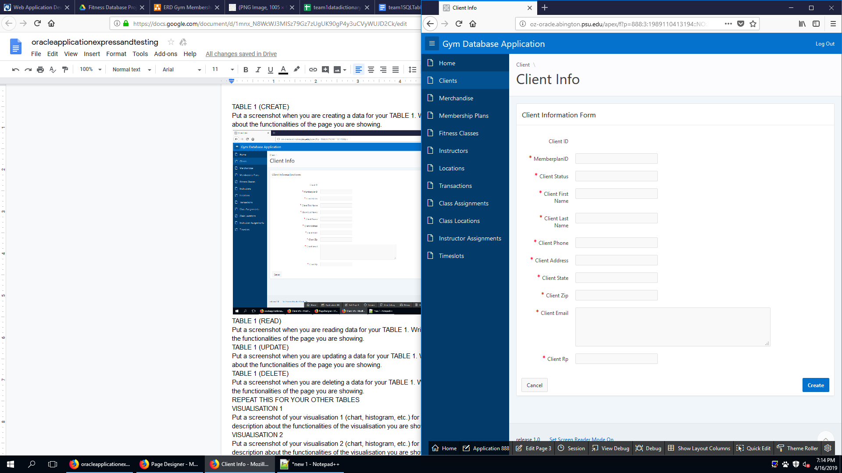

This is the CREATE page of the Clients table, it allows the entry of new new clients.

CLIENT (READ)

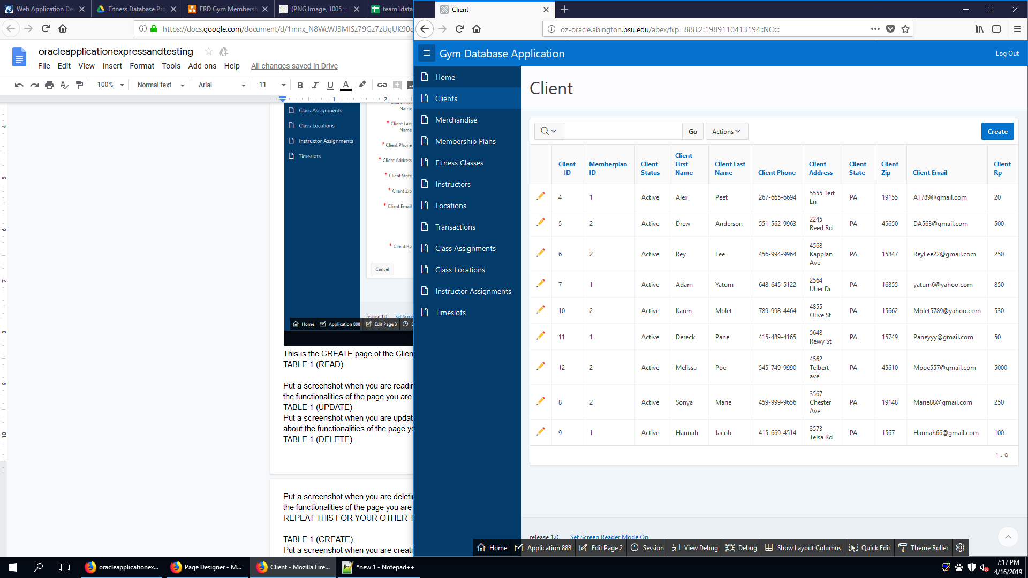

This is the READ page of the client table. It allows for the user to see all the clients

CLIENT (UPDATE)

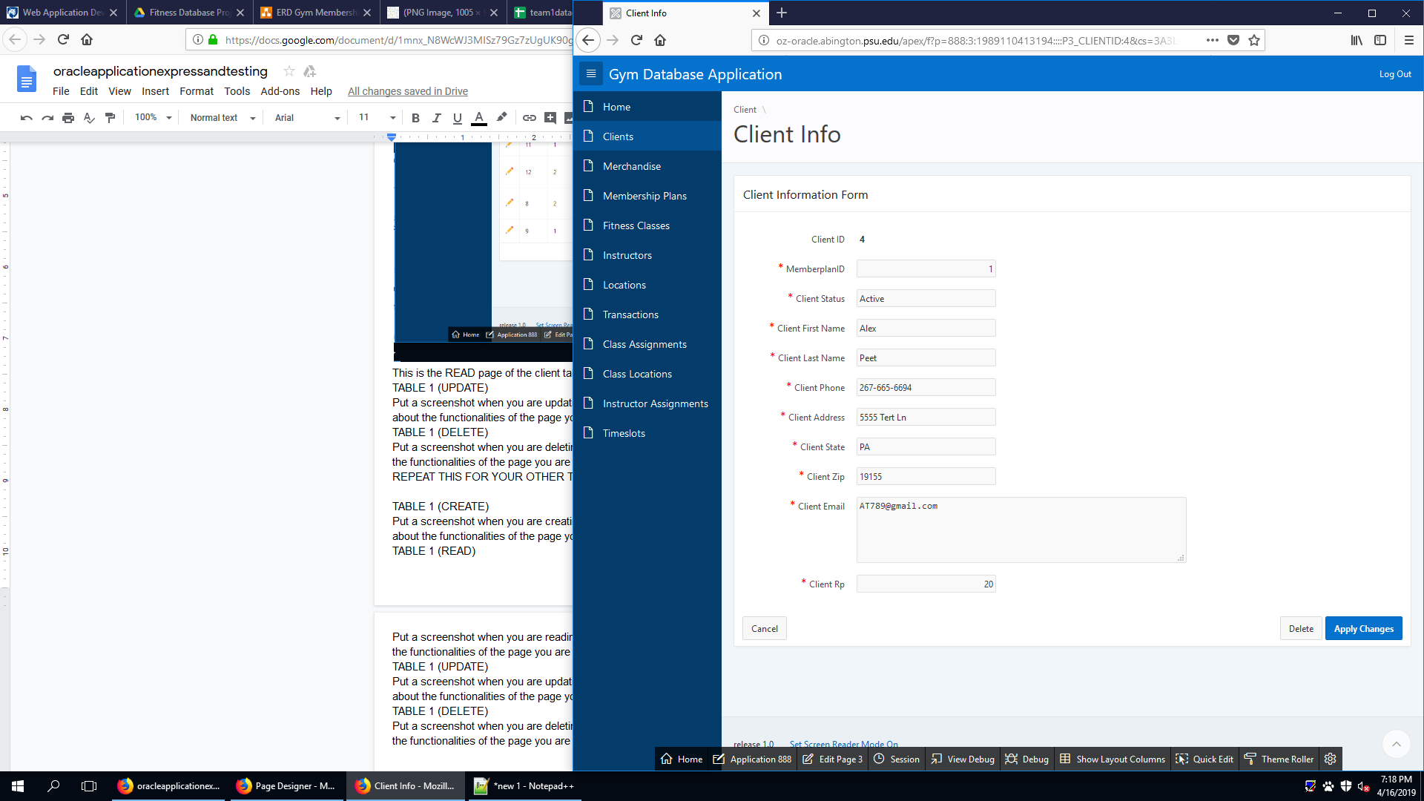

This is the UPDATE page of the client table. It allows for the user to update a currently existing customer.

CLIENT (DELETE)

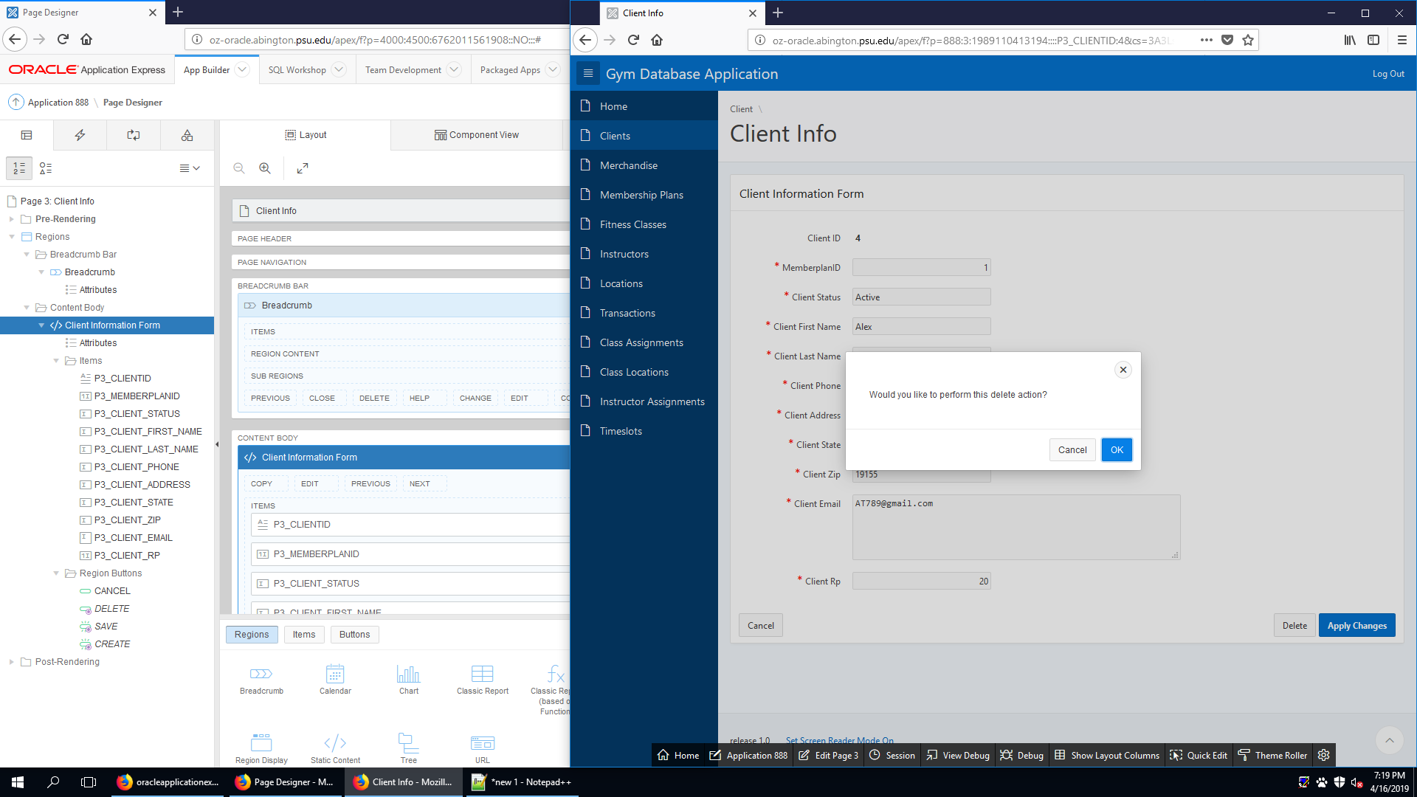

This is the DELETE page of the client table. It allows the user to delete an existing client.

MERCHANDISE (CREATE)

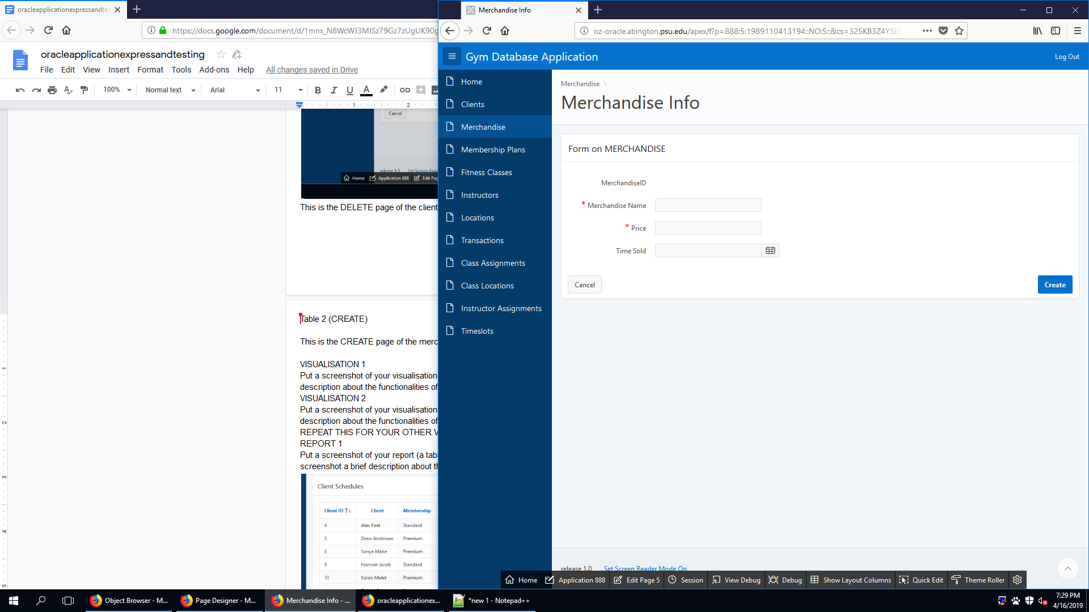

This is the CREATE page of the merchandise table. It allows the user to create new merchandise.

MERCHANDISE (READ)

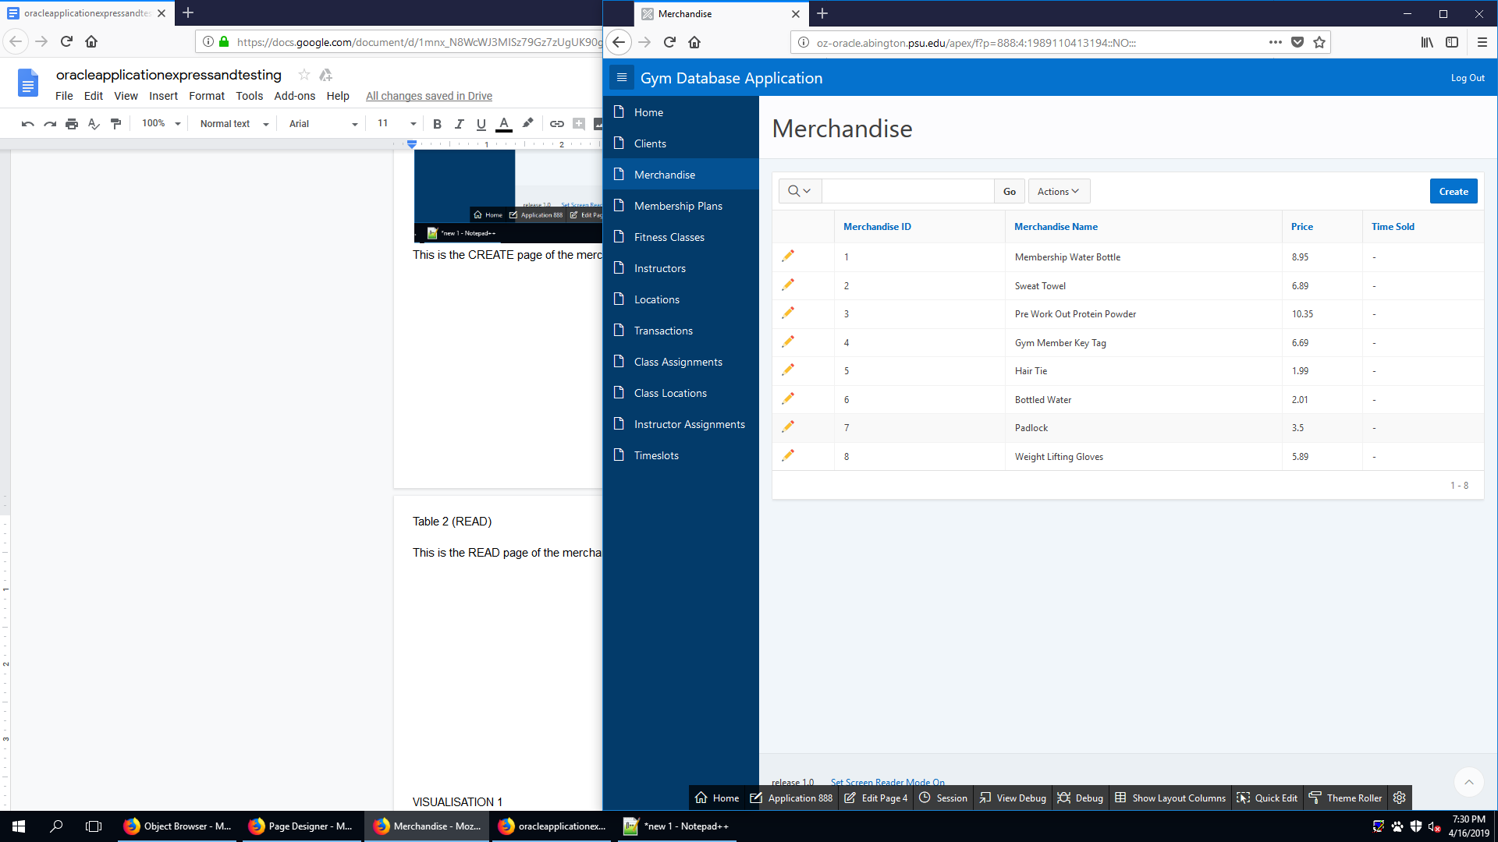

This is the READ page of the merchandise table. It allows the user to see existing merchandise.

MERCHANDISE (UPDATE)

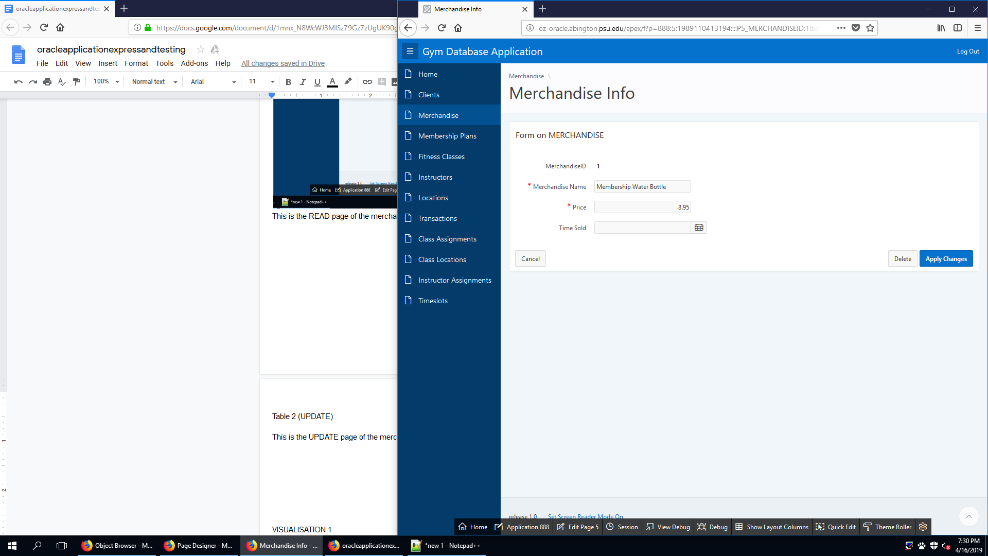

This is the UPDATE page of the merchandise table. It allows the user to update an existing merchandise.

MERCANDISE (DELETE)

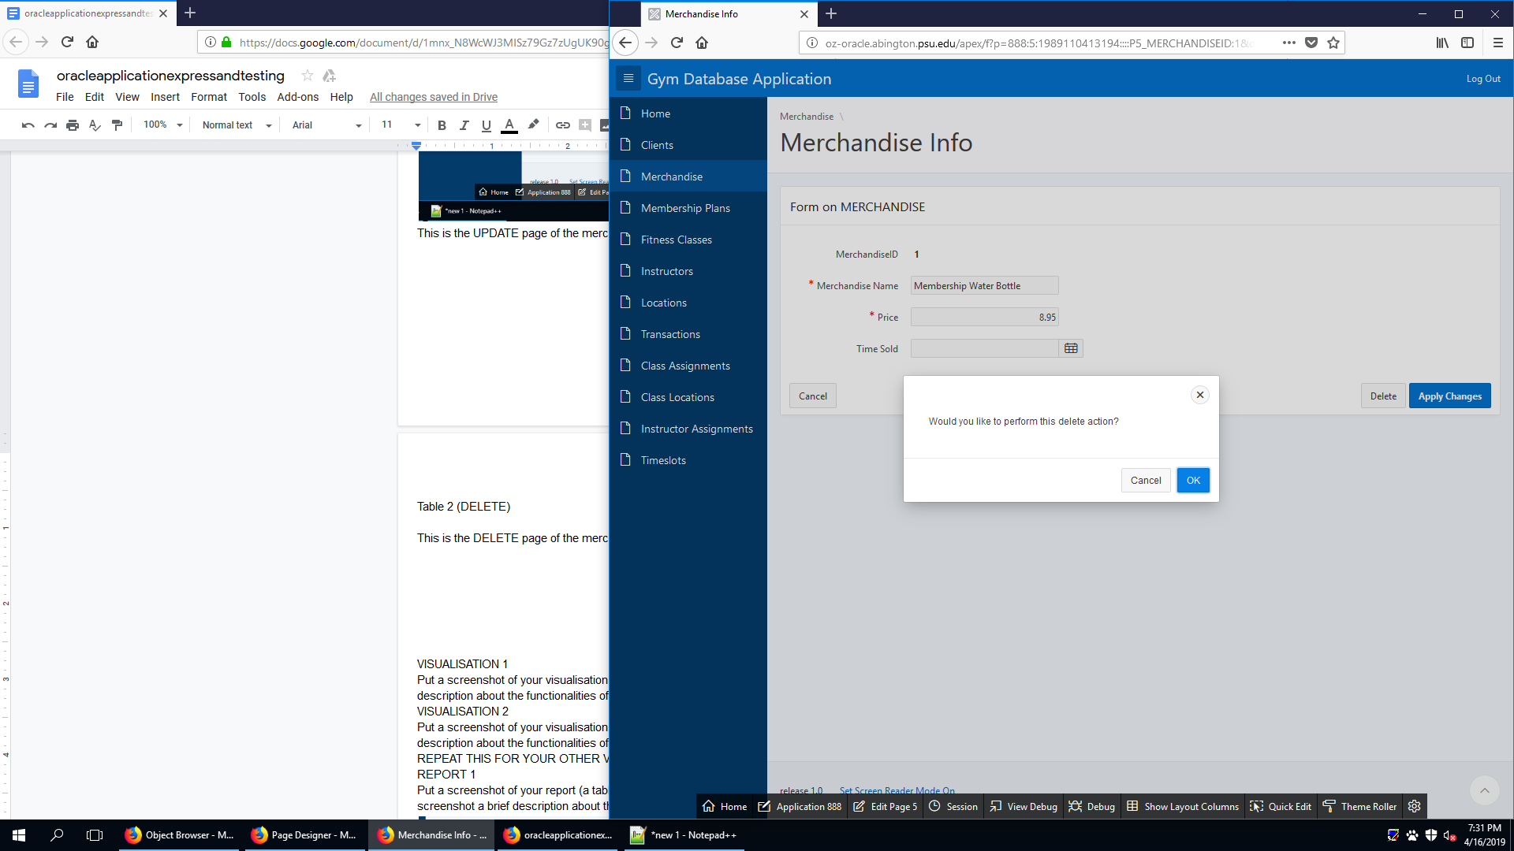

This is the DELETE page of the merchandise table. It allows the user to delete an existing merchandise.

MEMBERPLAN (CREATE)

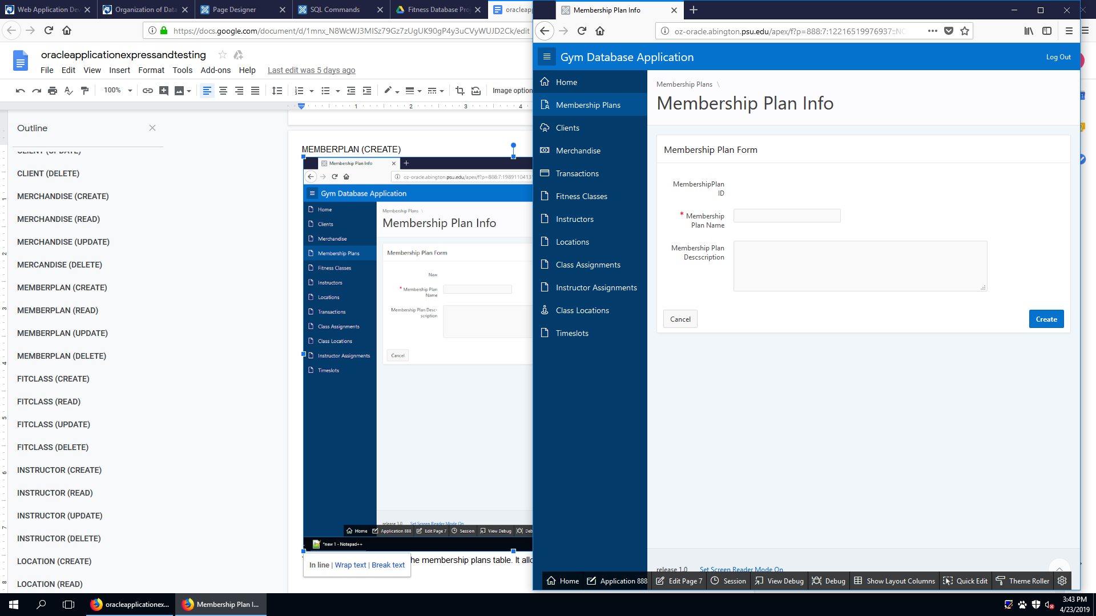

This is the CREATE page of the membership plans table. It allows the user to create new membership plans.

MEMBERPLAN (READ)

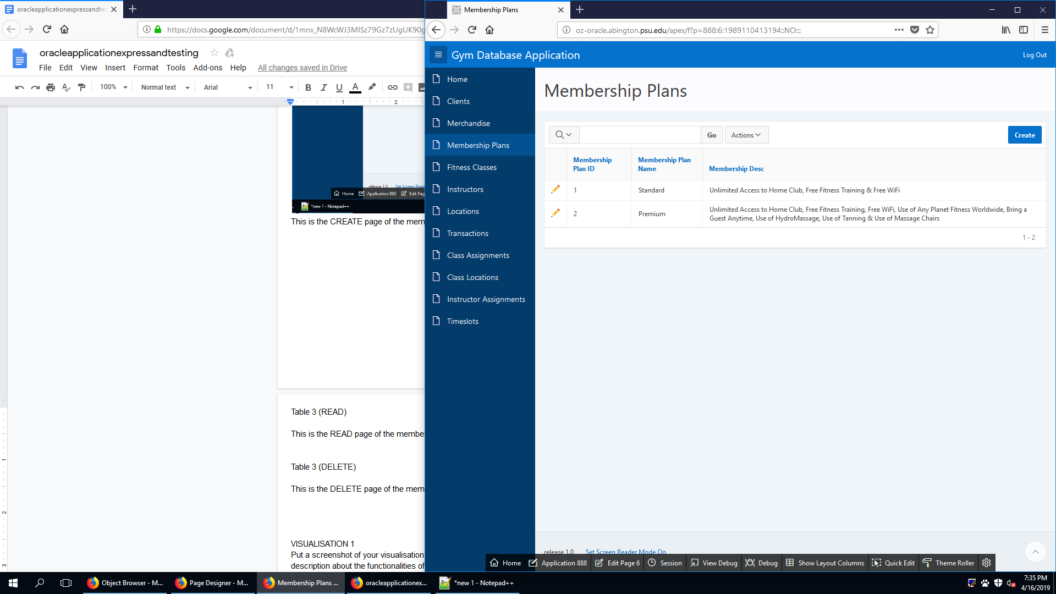

This is the READ page of the membership plans table. It allows the user to see existing membership plans.

MEMBERPLAN (UPDATE)

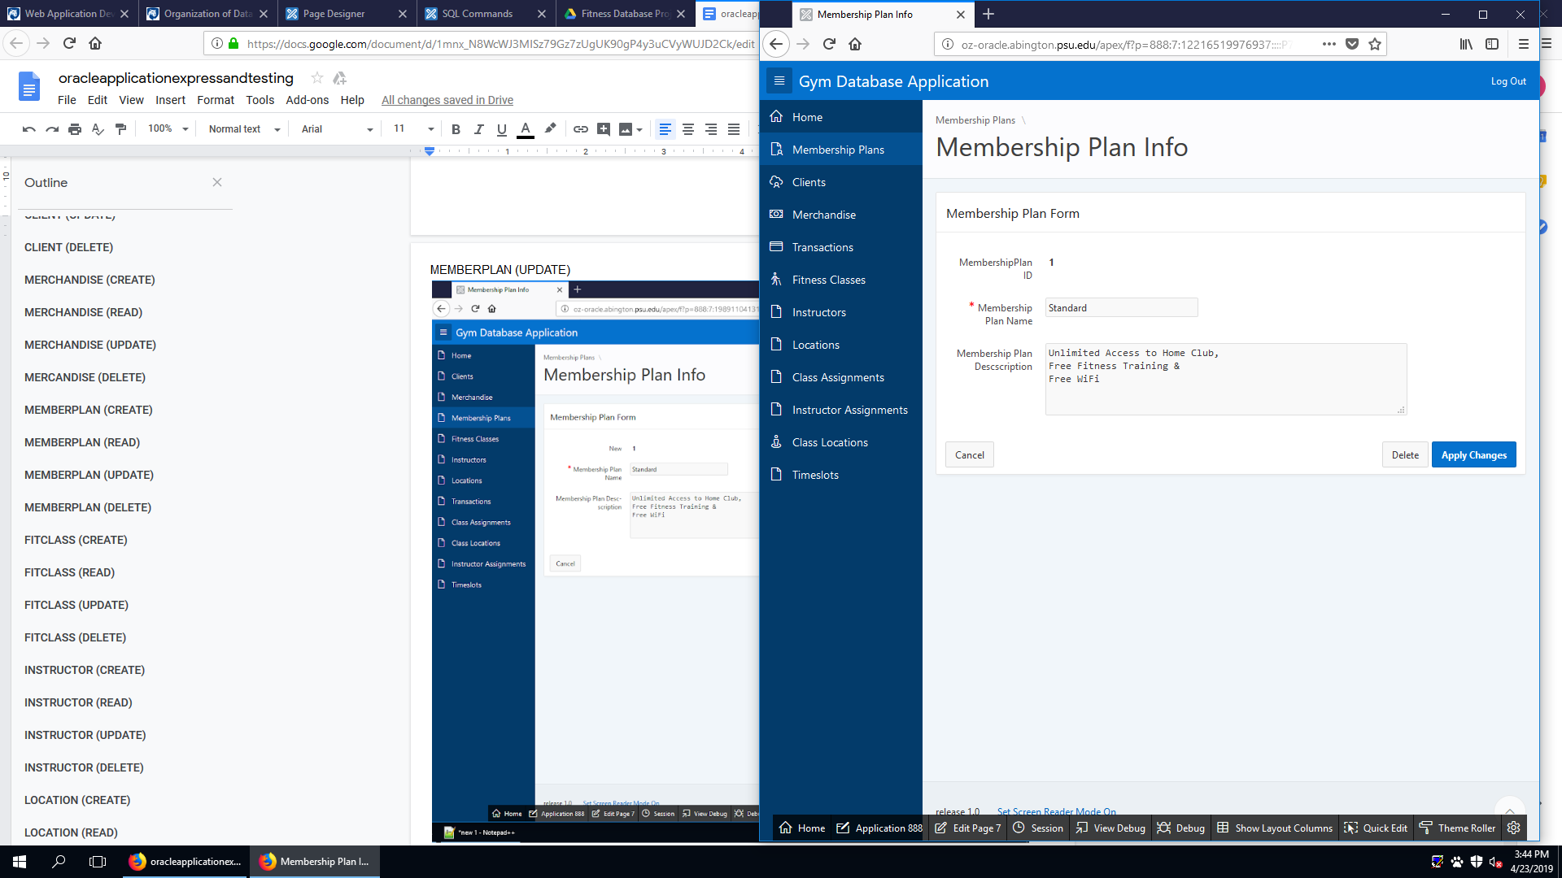

This is the UPDATE page of the membership plans table. It allows the user to update an existing membership plans.

MEMBERPLAN (DELETE)

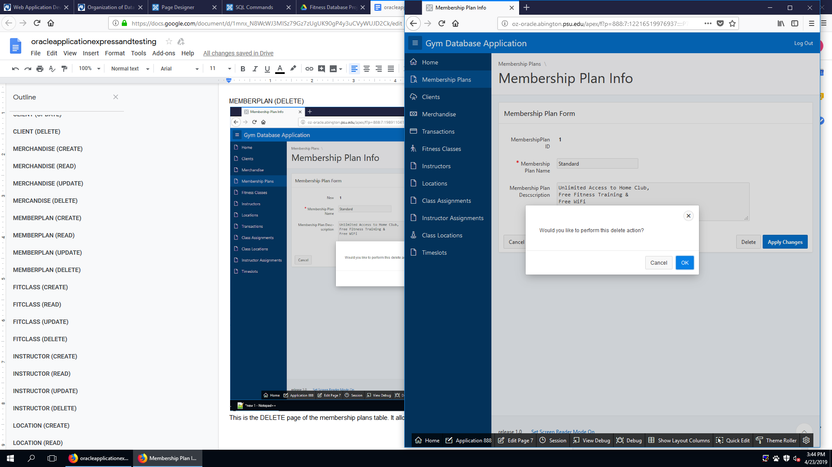

This is the DELETE page of the membership plans table. It allows the user to delete existing membership plans.

FITCLASS (CREATE)

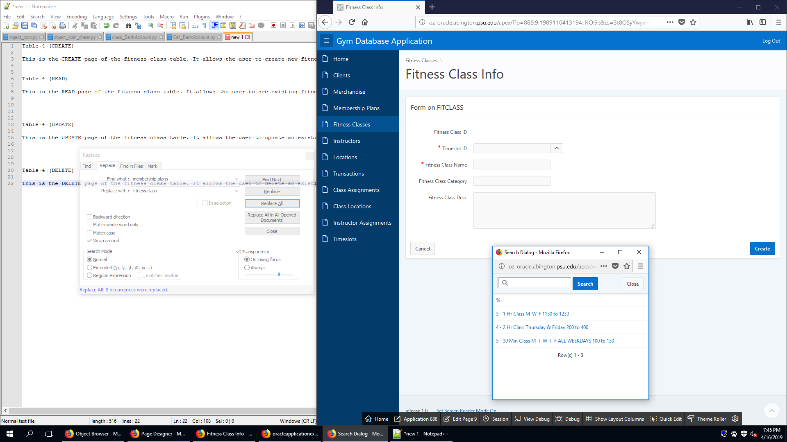

This is the CREATE page of the fitness class table. It allows the user to create a new fitness class.

FITCLASS (READ)

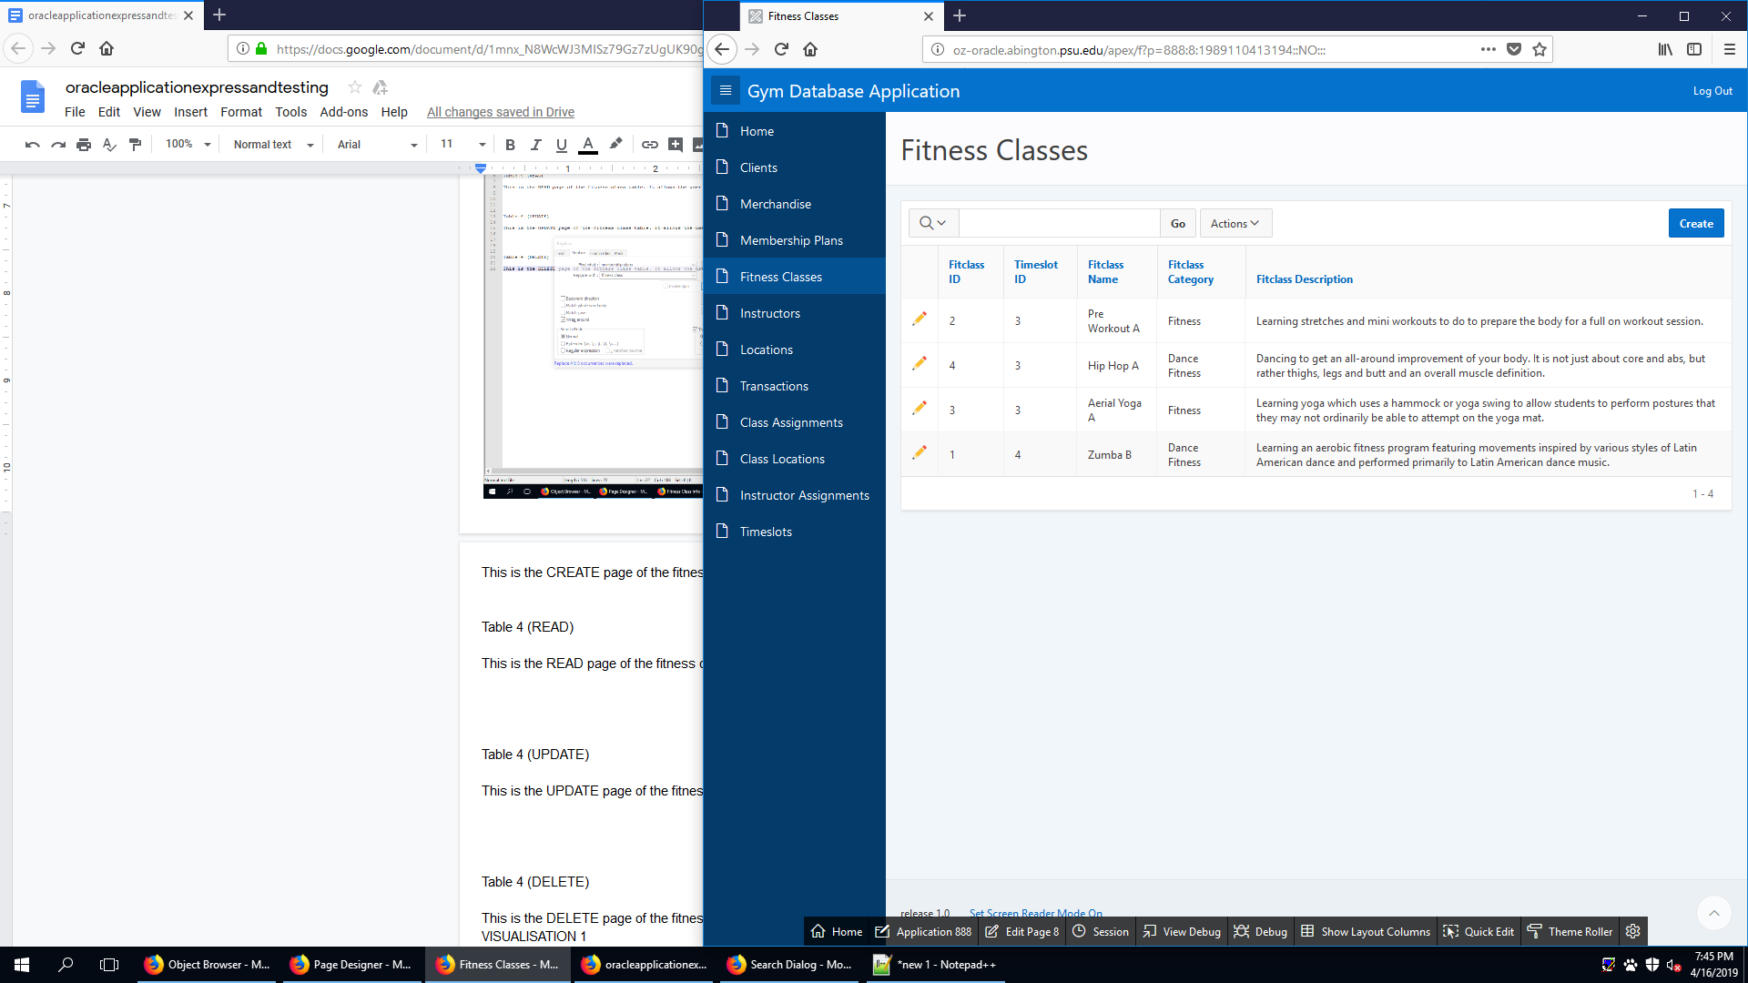

This is the READ page of the fitness class table. It allows the user to see existing fitness class.

FITCLASS (UPDATE)

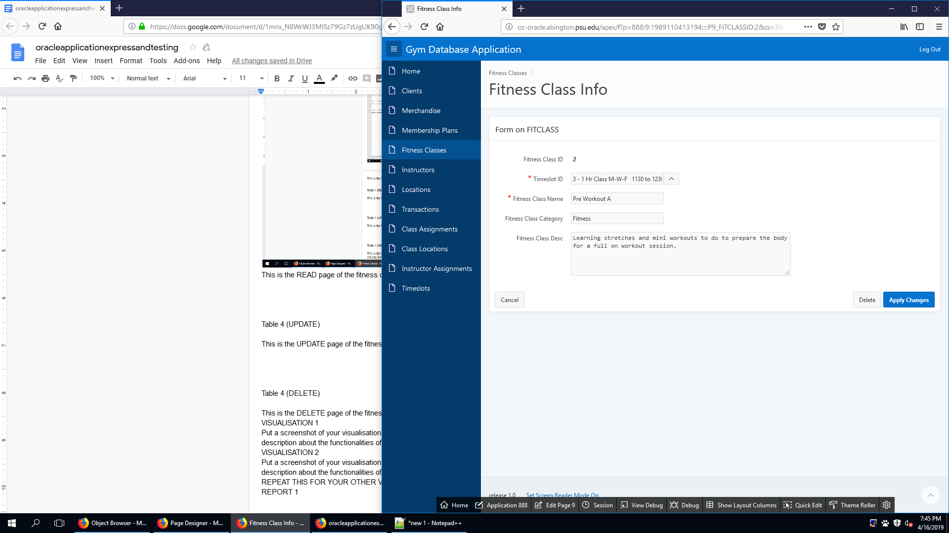

This is the UPDATE page of the fitness class table. It allows the user to update an existing fitness class.

FITCLASS (DELETE)

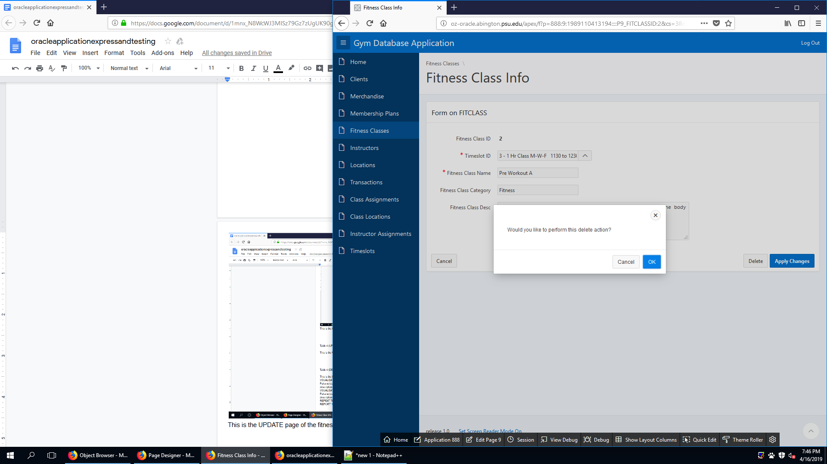

This is the DELETE page of the fitness class table. It allows the user to delete an existing fitness class.

INSTRUCTOR (CREATE)

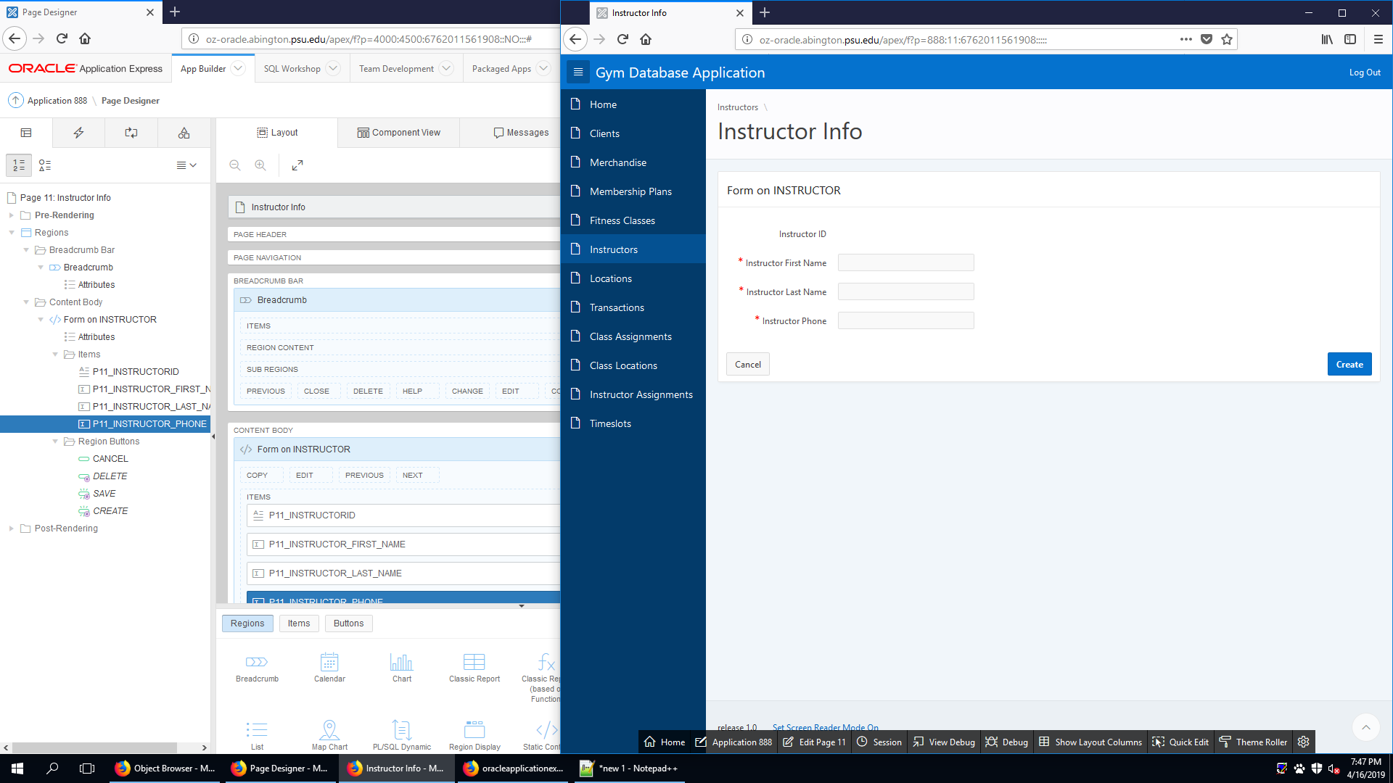

This is the CREATE page of the instructor table. It allows the user to create new instructor.

INSTRUCTOR (READ)

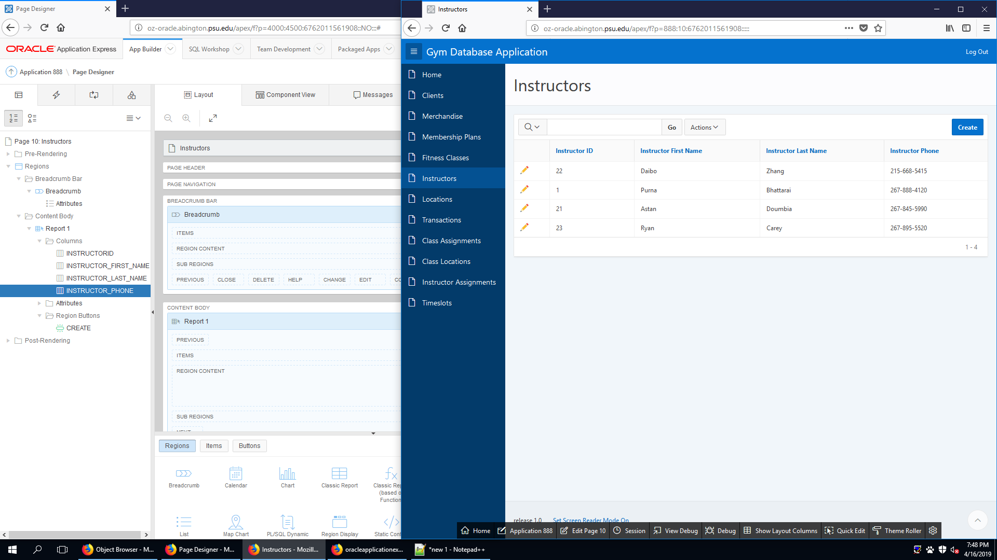

This is the READ page of the instructor table. It allows the user to see existing instructor.

INSTRUCTOR (UPDATE)

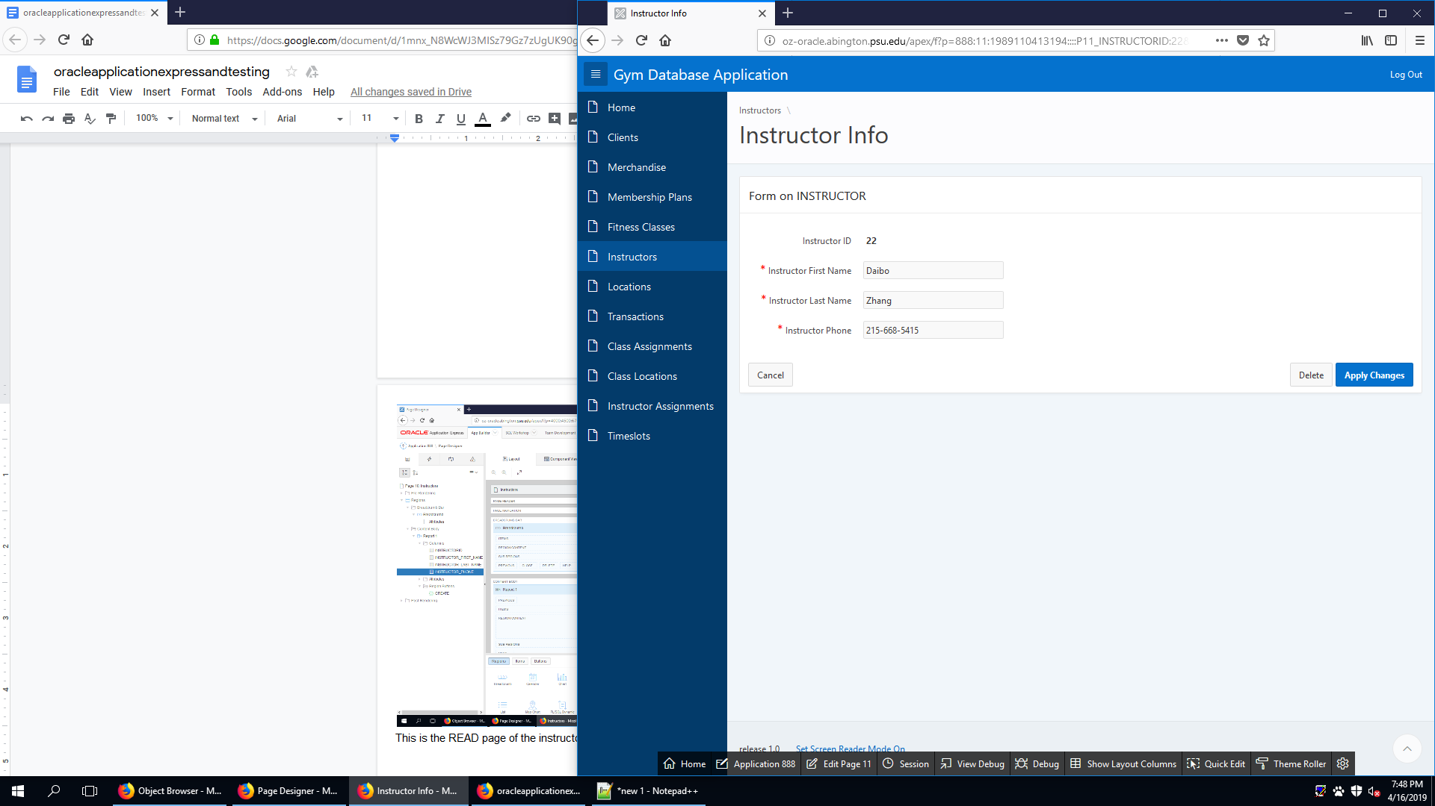

This is the UPDATE page of the instructor table. It allows the user to update an existing instructor.

INSTRUCTOR (DELETE)

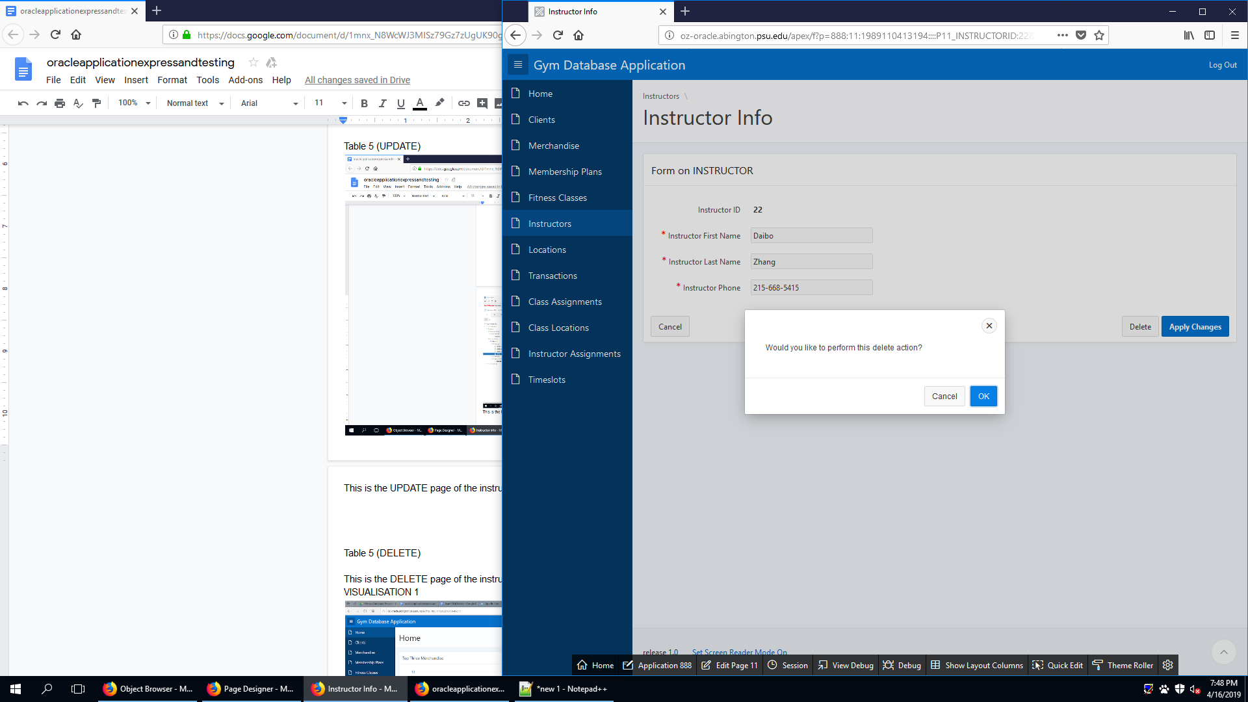

This is the DELETE page of the instructor table. It allows the user to delete an existing instructor.

LOCATION (CREATE)

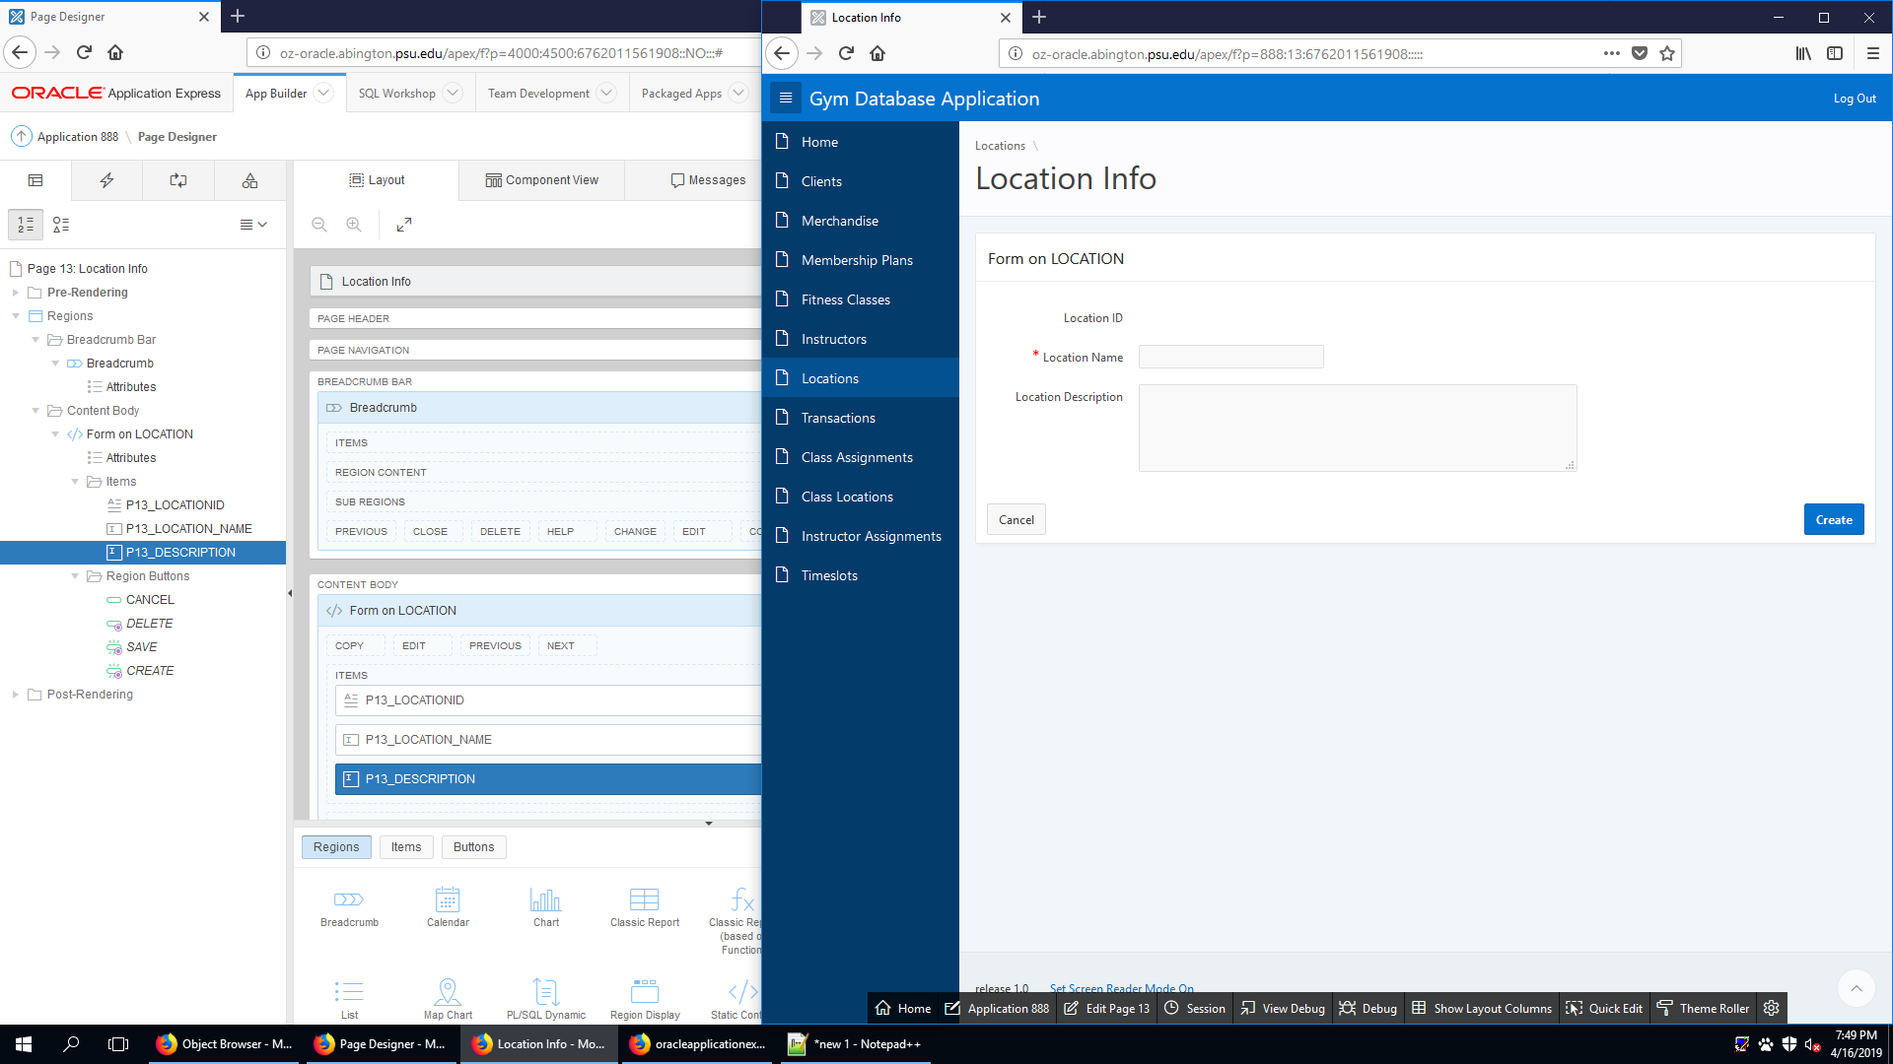

This is the CREATE page of the location table. It allows the user to create new location.

LOCATION (READ)

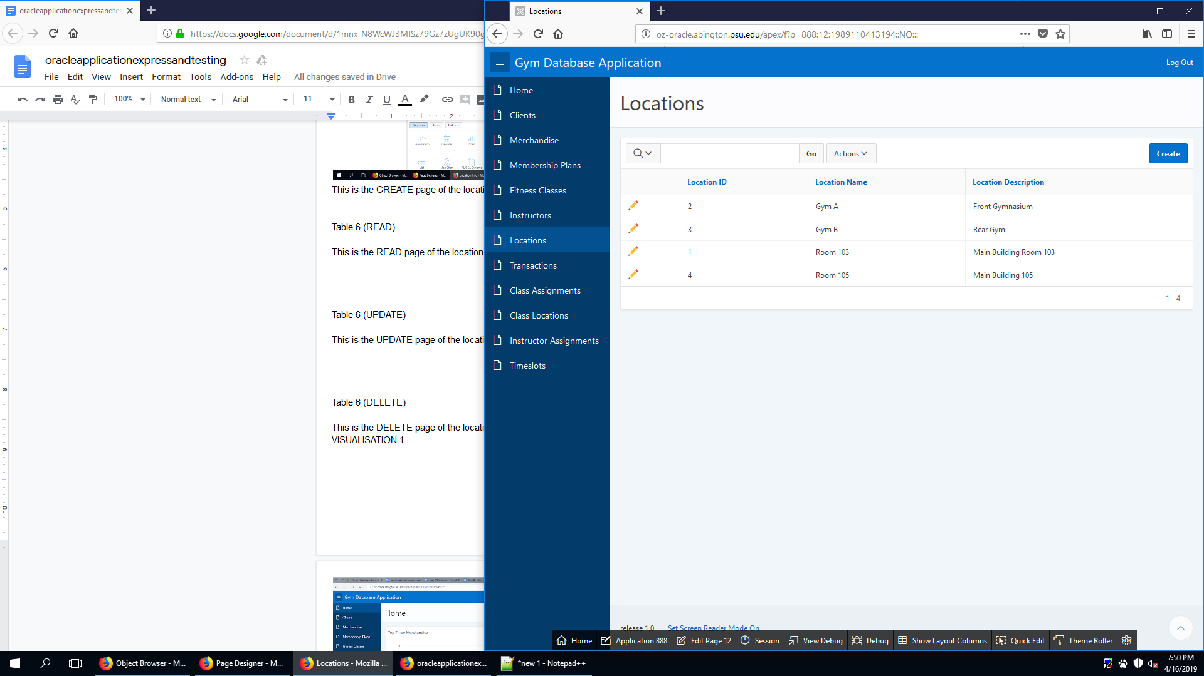

This is the READ page of the location table. It allows the user to see existing location.

LOCATION (UPDATE)

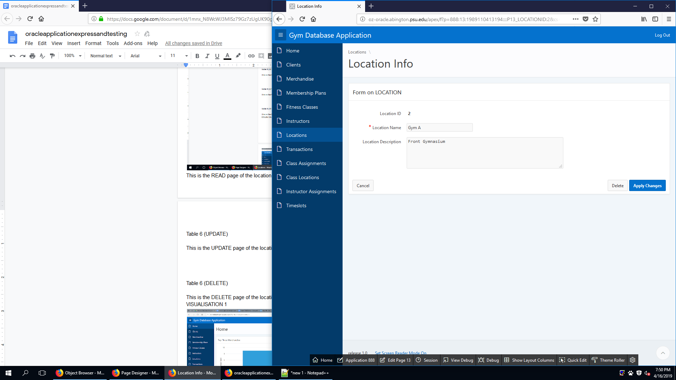

This is the UPDATE page of the location table. It allows the user to update an existing location.

LOCATION (DELETE)

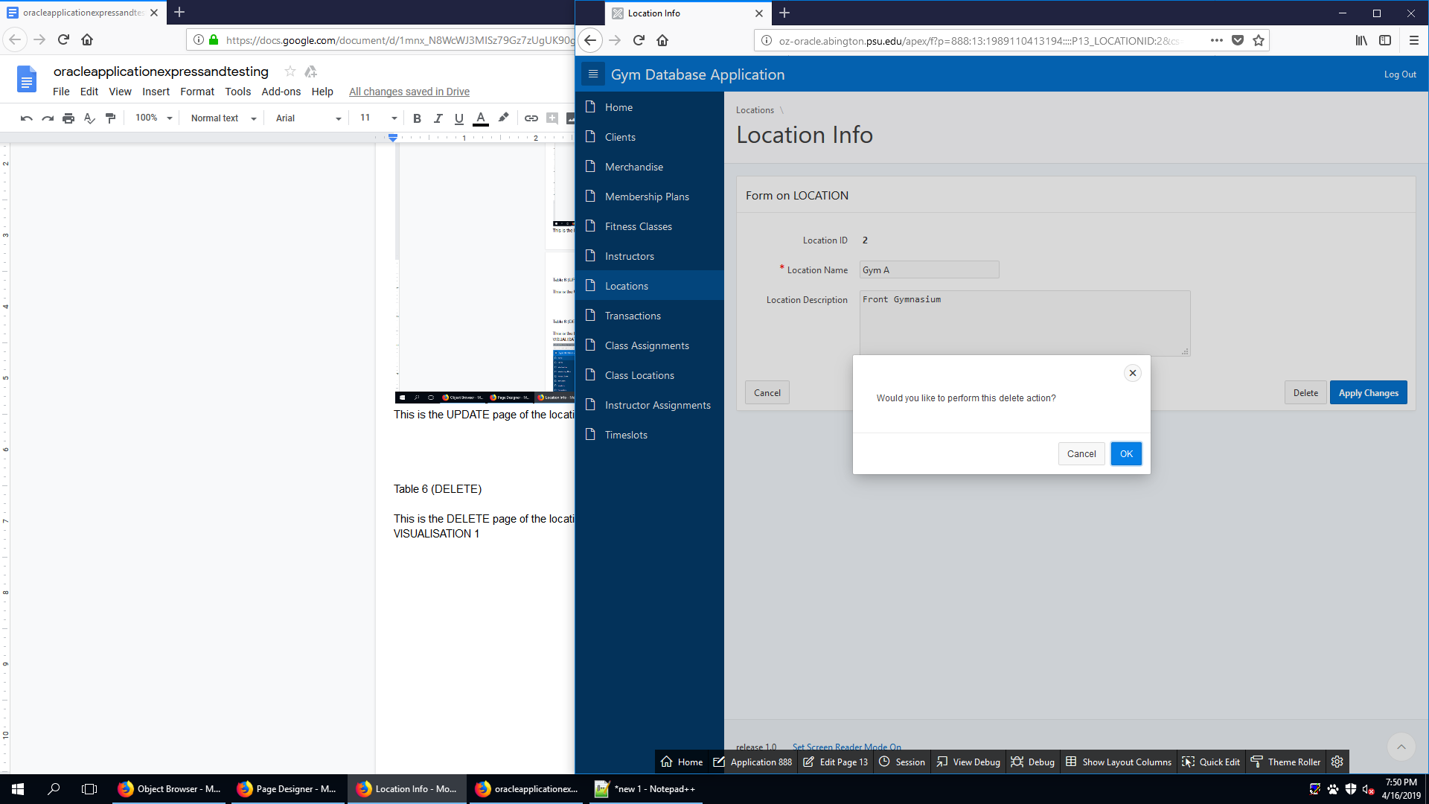

This is the DELETE page of the location table. It allows the user to delete an existing location.

CLIENTMERCHANDISE (CREATE)

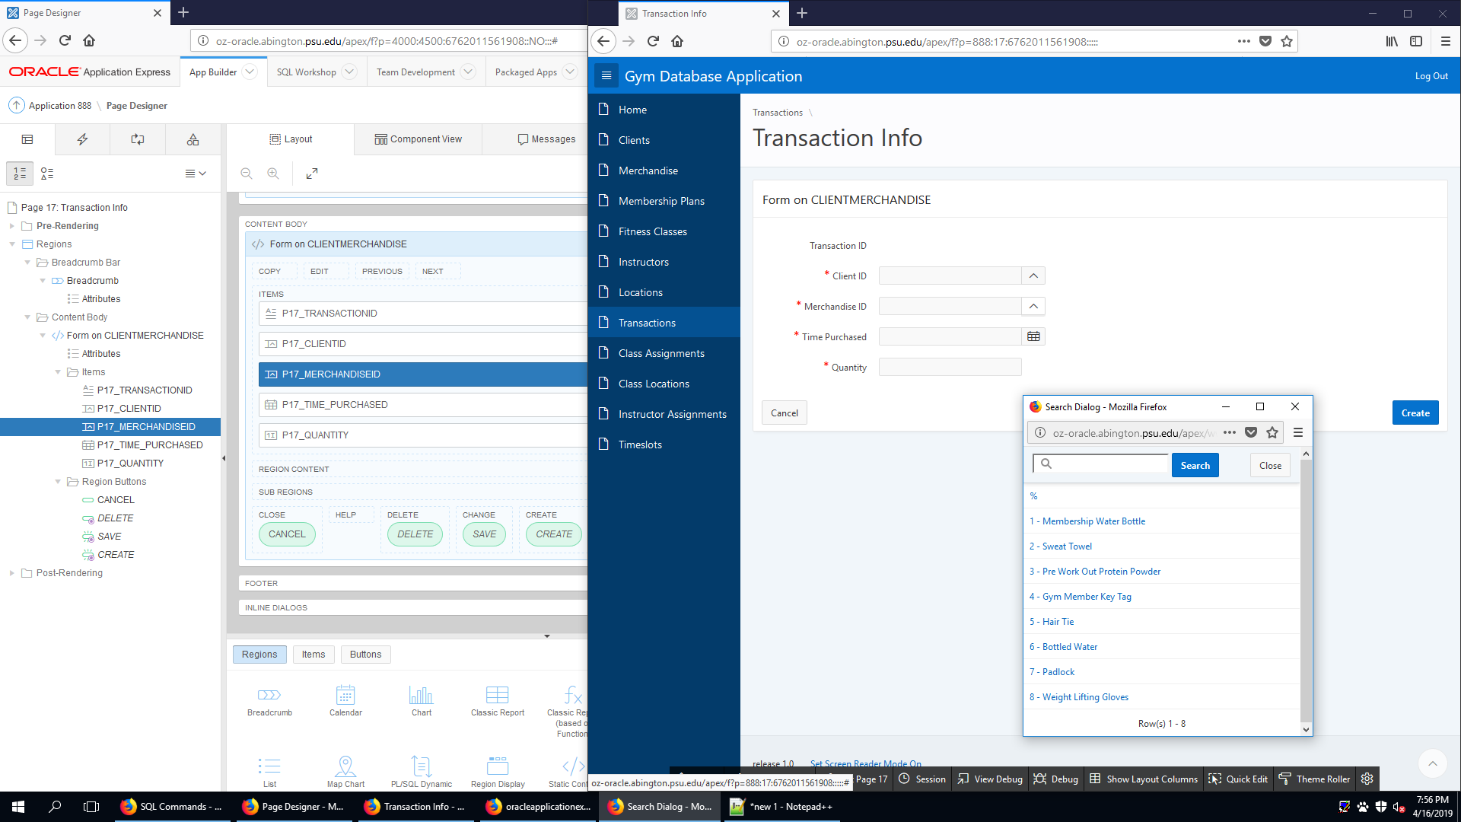

This is the CREATE page of the clientmerchandise table. It allows the user to create new transaction.

CLIENTMERCHANDISE (READ)

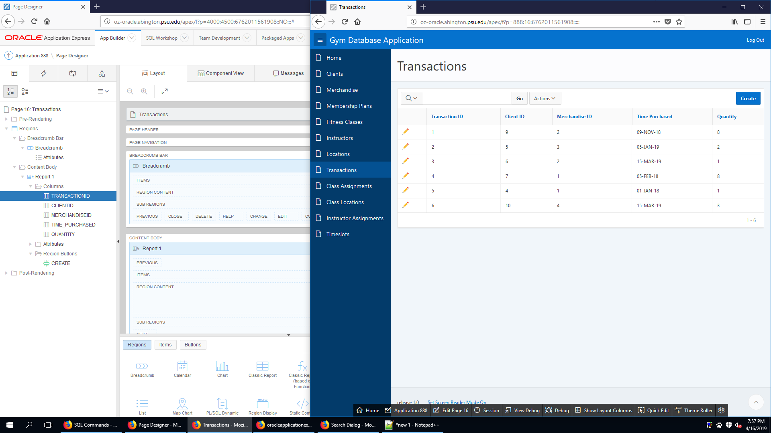

This is the READ page of the clientmerchandise table. It allows the user to see existing transaction.

CLIENTMERCHANDISE (UPDATE)

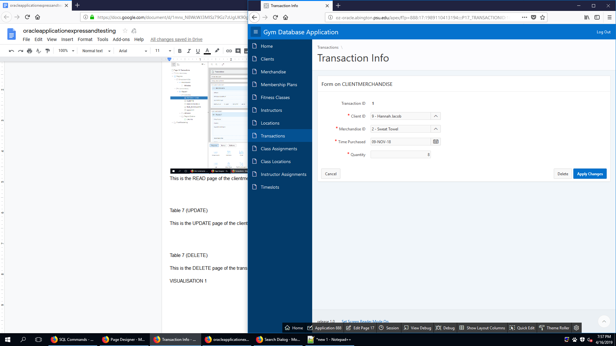

This is the UPDATE page of the clientmerchandise table. It allows the user to update an existing transaction.

CLIENTMERCHANDISE (DELETE)

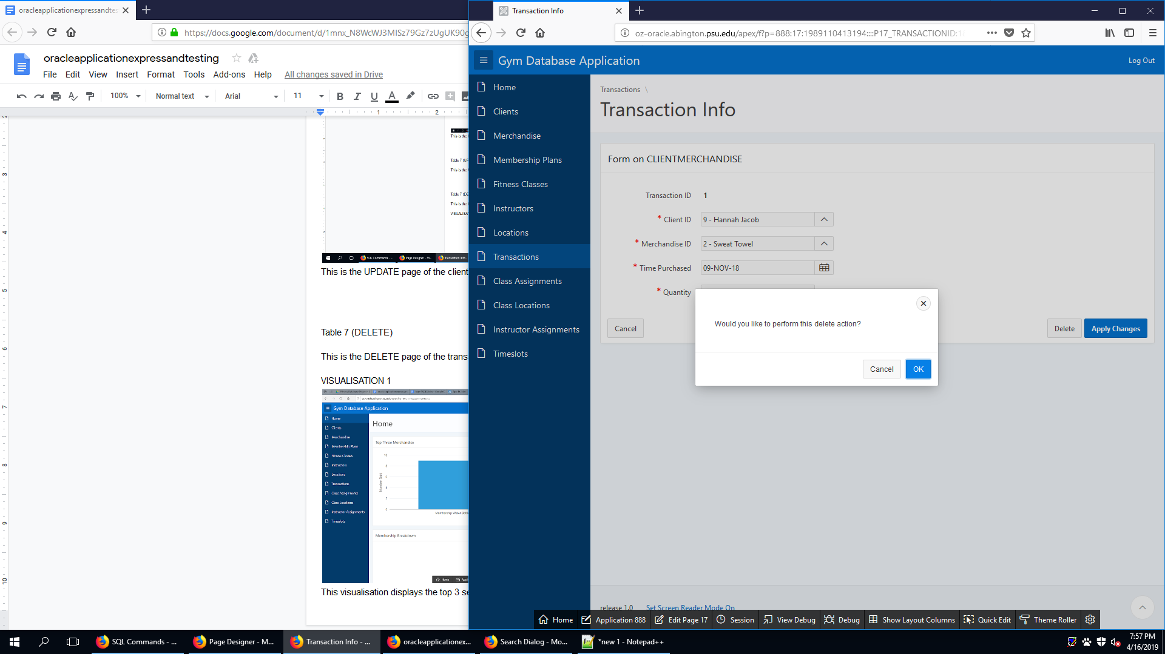

This is the DELETE page of the transaction table. It allows the user to delete an existing transaction.

FITCLASSCLIENT (CREATE)

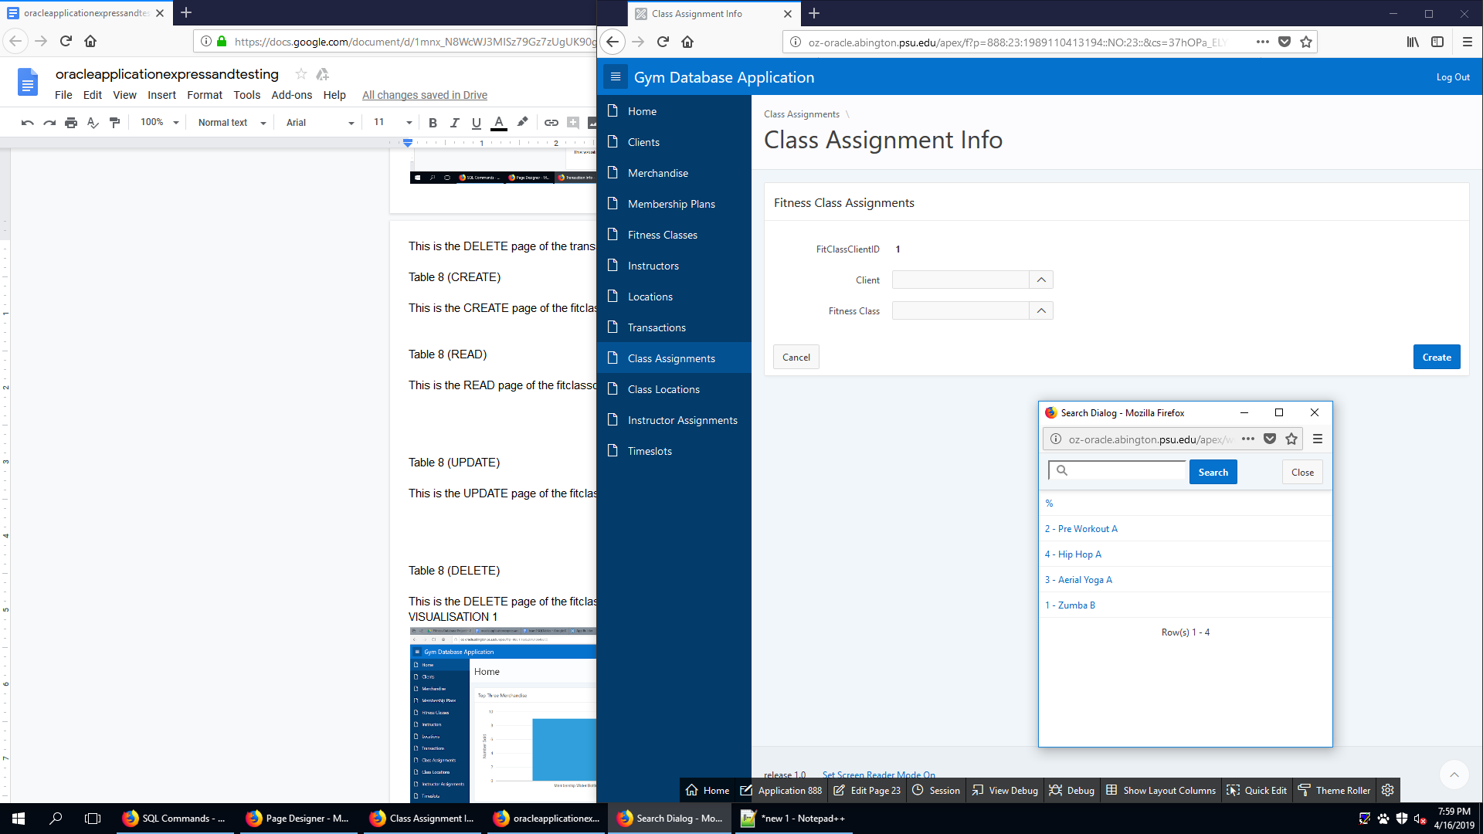

This is the CREATE page of the fitclassclient table. It allows the user to create a new class assignment.

FITCLASSCLIENT (READ)

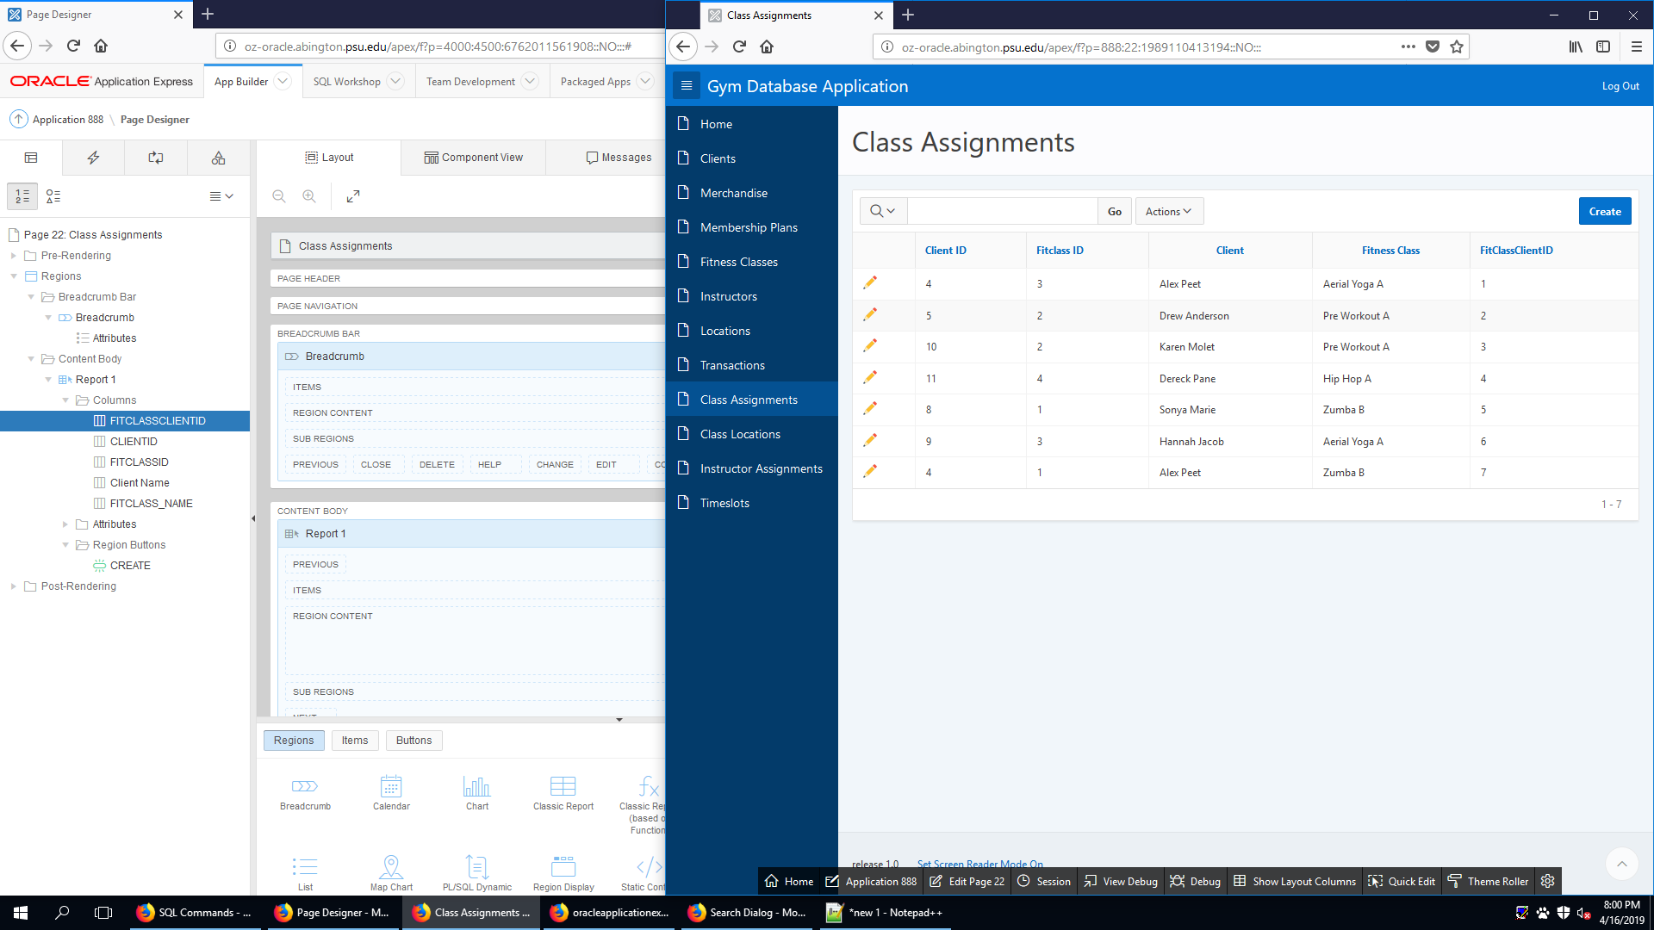

This is the READ page of the fitclassclient table. It allows the user to see an existing class assignment.

FITCLASSCLIENT (UPDATE)

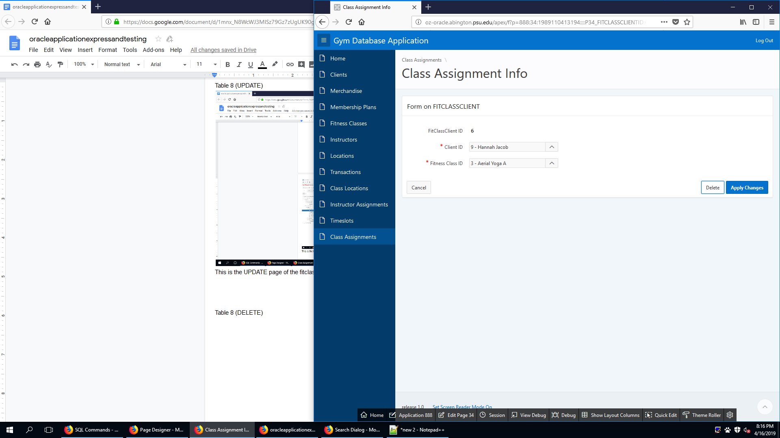

This is the UPDATE page of the fitclassclient table. It allows the user to update an existing class assignment.

FITCLASSCLIENT (DELETE)

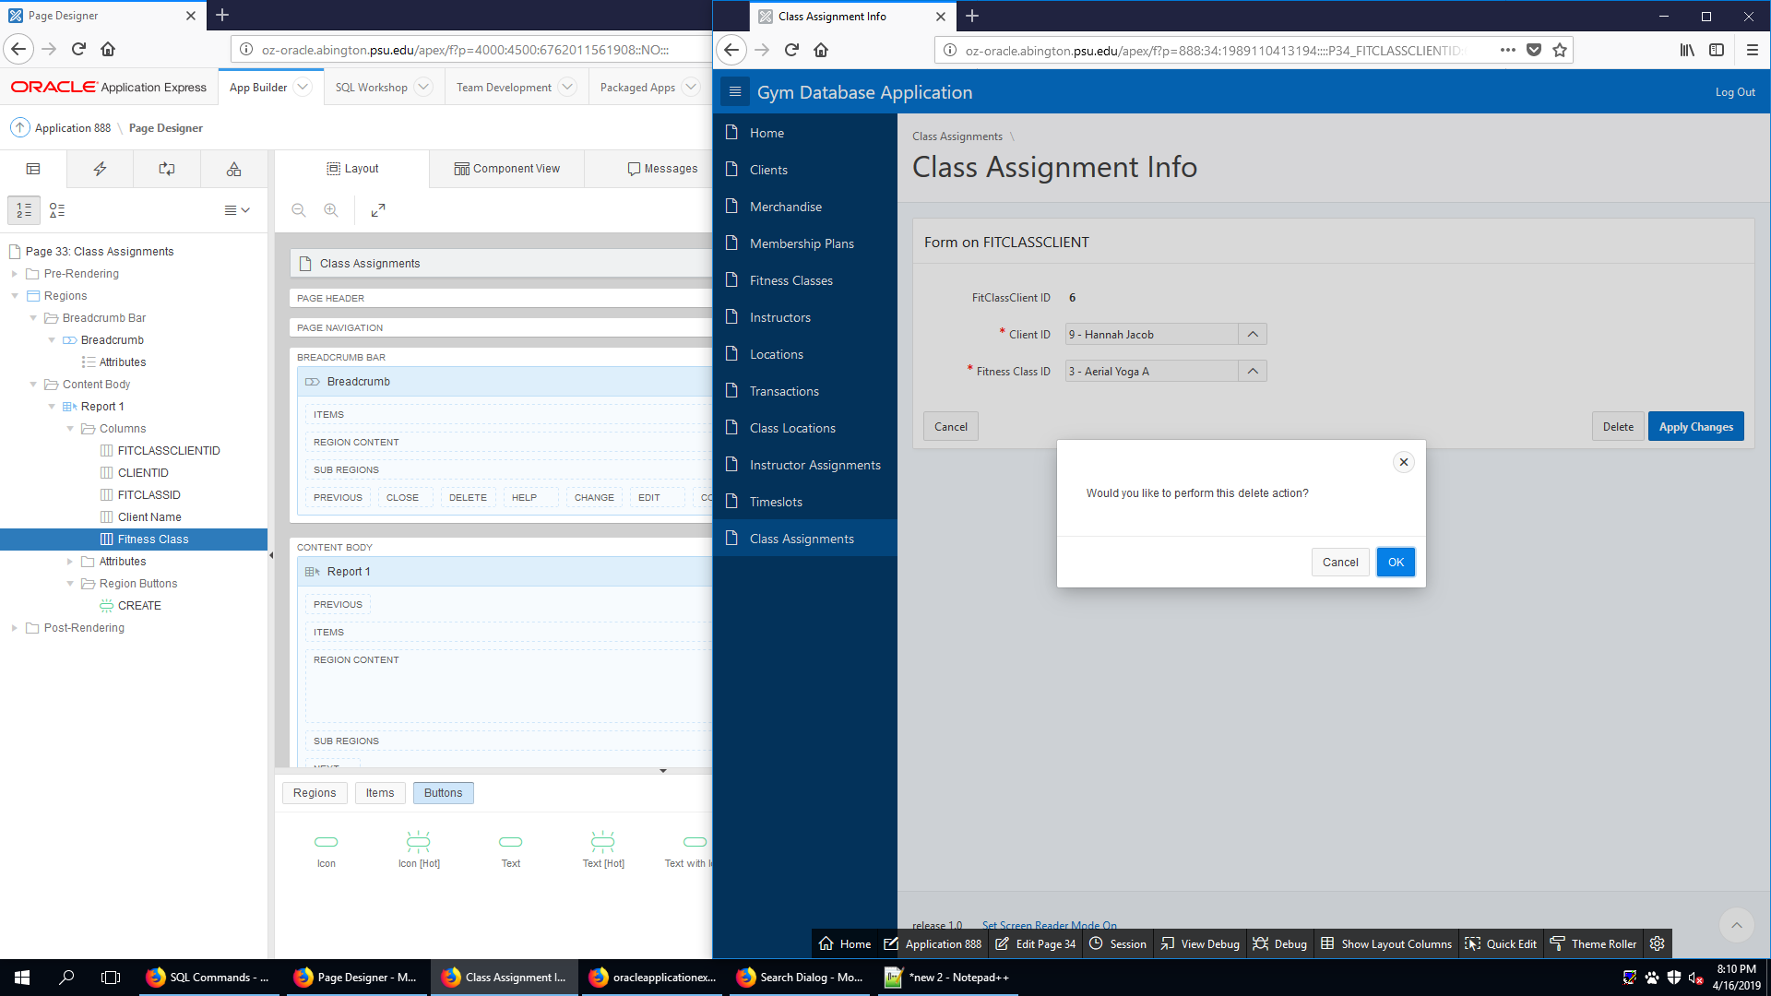

This is the DELETE page of the fitclassclient table. It allows the user to delete an existing class assignment.

FITCLASSINSTRUCTOR (CREATE)

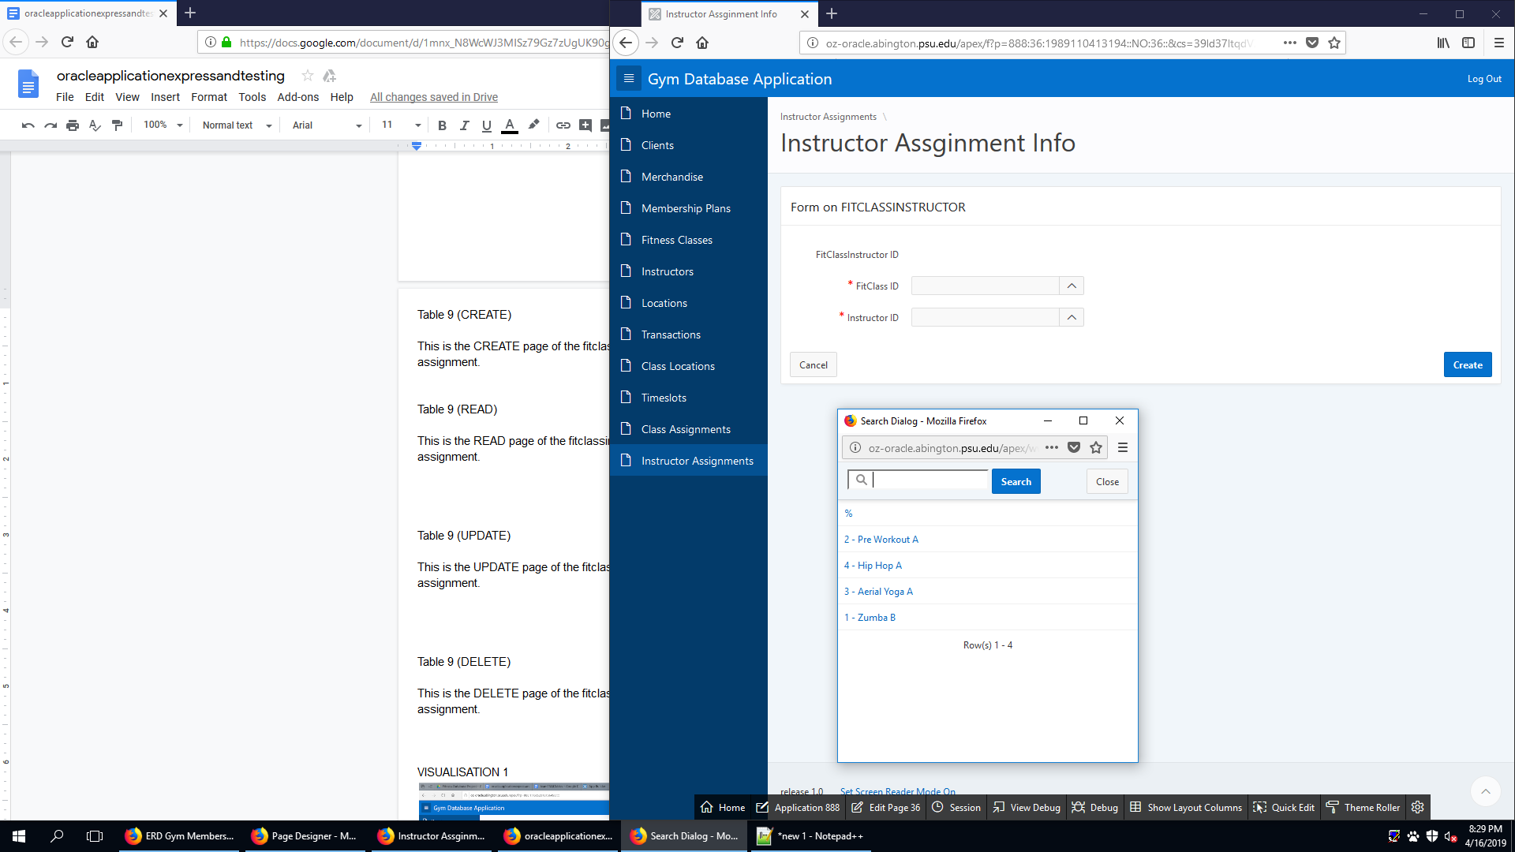

This is the CREATE page of the fitclassinstructor assignment table. It allows the user to create new instructor assignment.

FITCLASSINSTRUCTOR (READ)

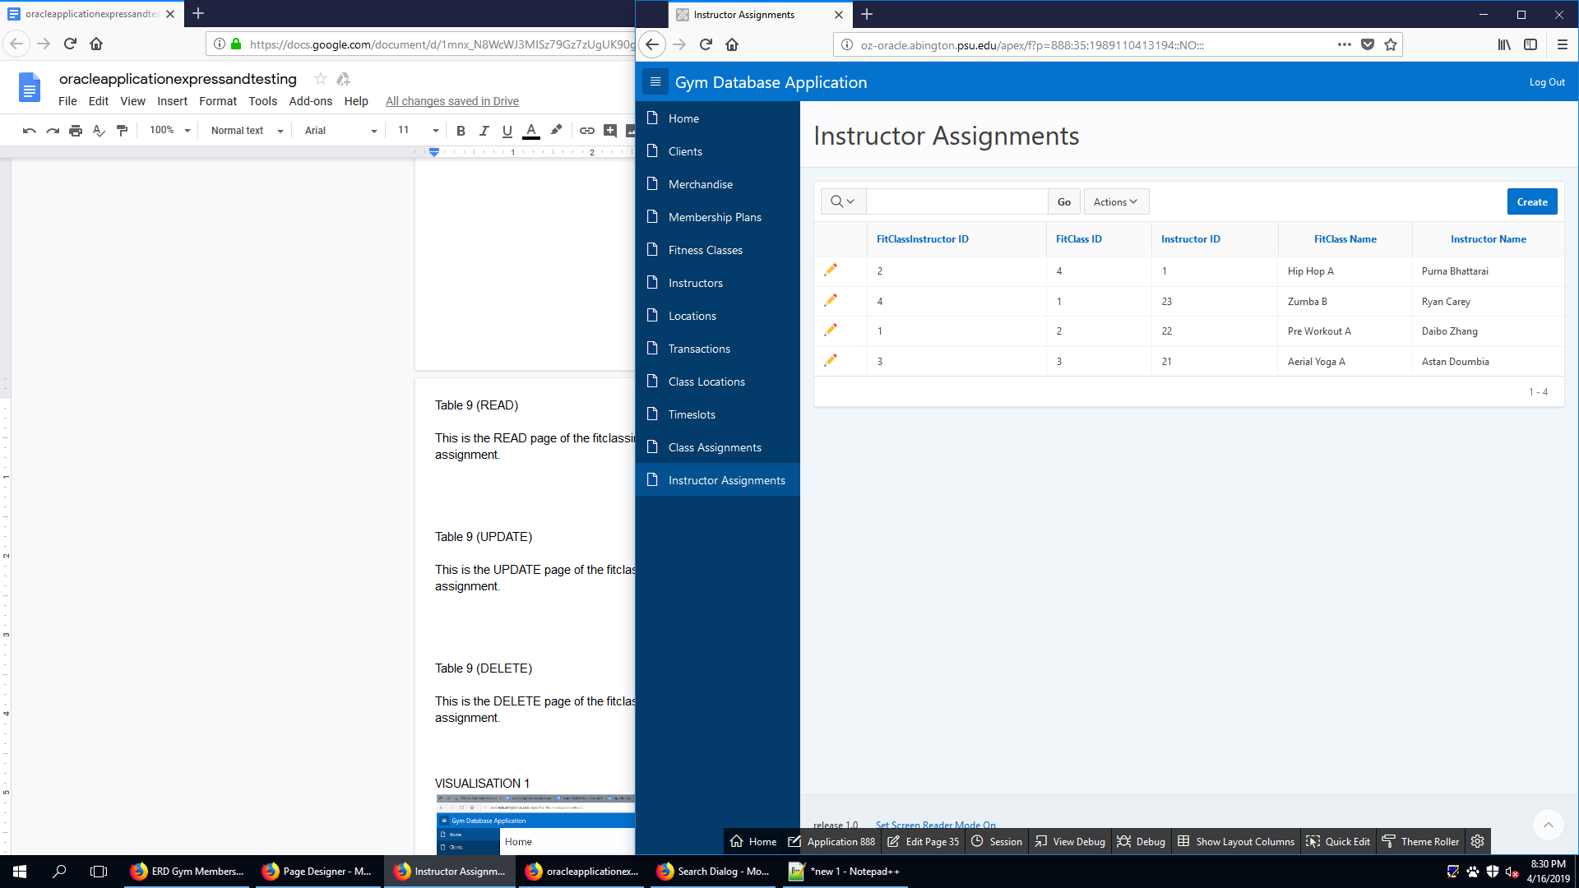

This is the READ page of the fitclassinstructor assignment table. It allows the user to see existing instructor assignment.

FITCLASSINSTRUCTOR (UPDATE)

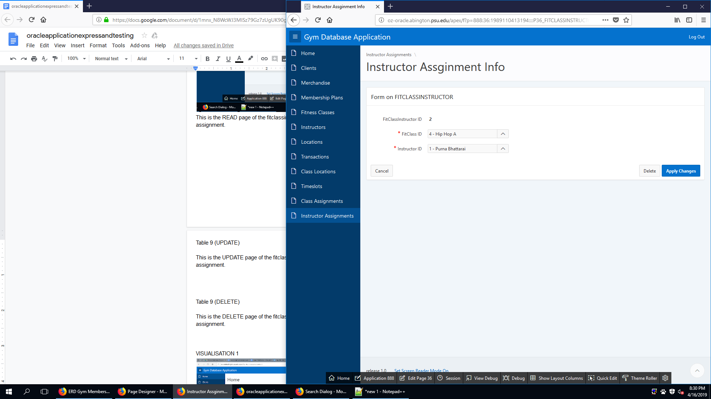

This is the UPDATE page of the fitclassinstructor assignment table. It allows the user to update an existing instructor assignment.

FITCLASSINSTRUCTOR (DELETE)

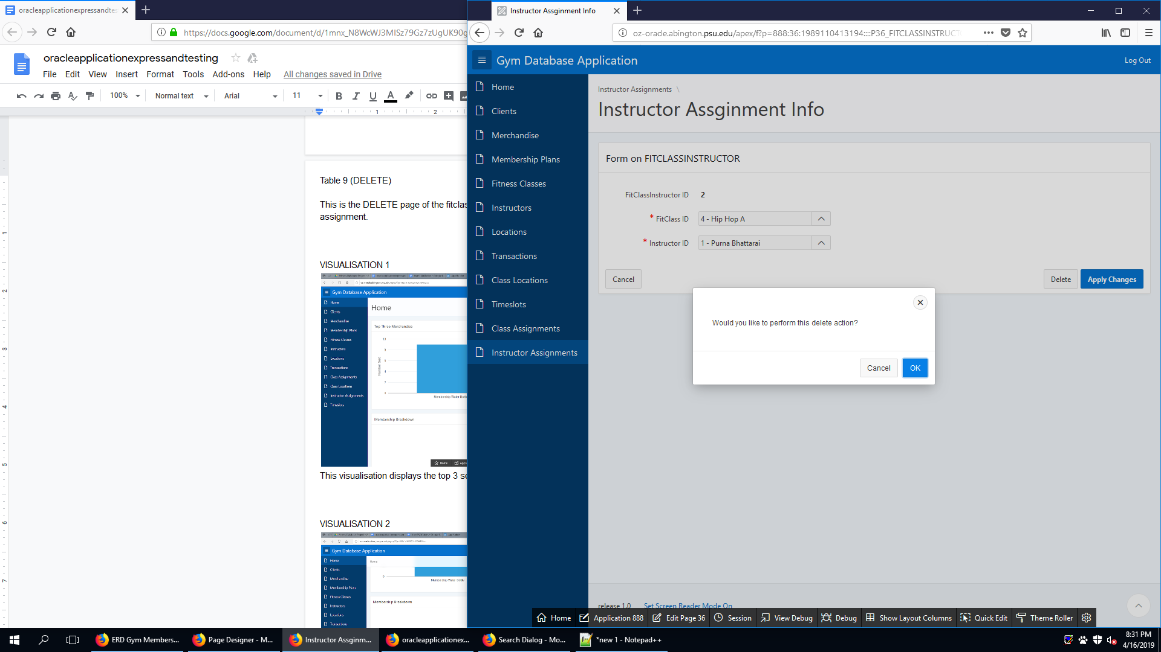

This is the DELETE page of the fitclassinstructor assignment table. It allows the user to delete an existing instructor assignment.

FITCLASSLOCATION(CREATE)

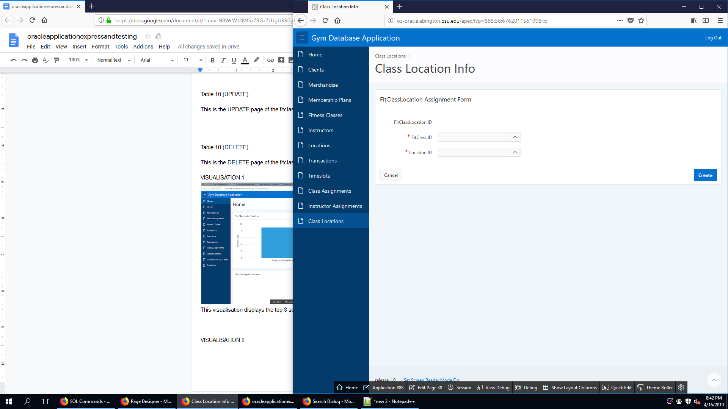

This is the CREATE page of the fitclasslocation table. It allows the user to create new class location.

FITCLASSLOCATION (READ)

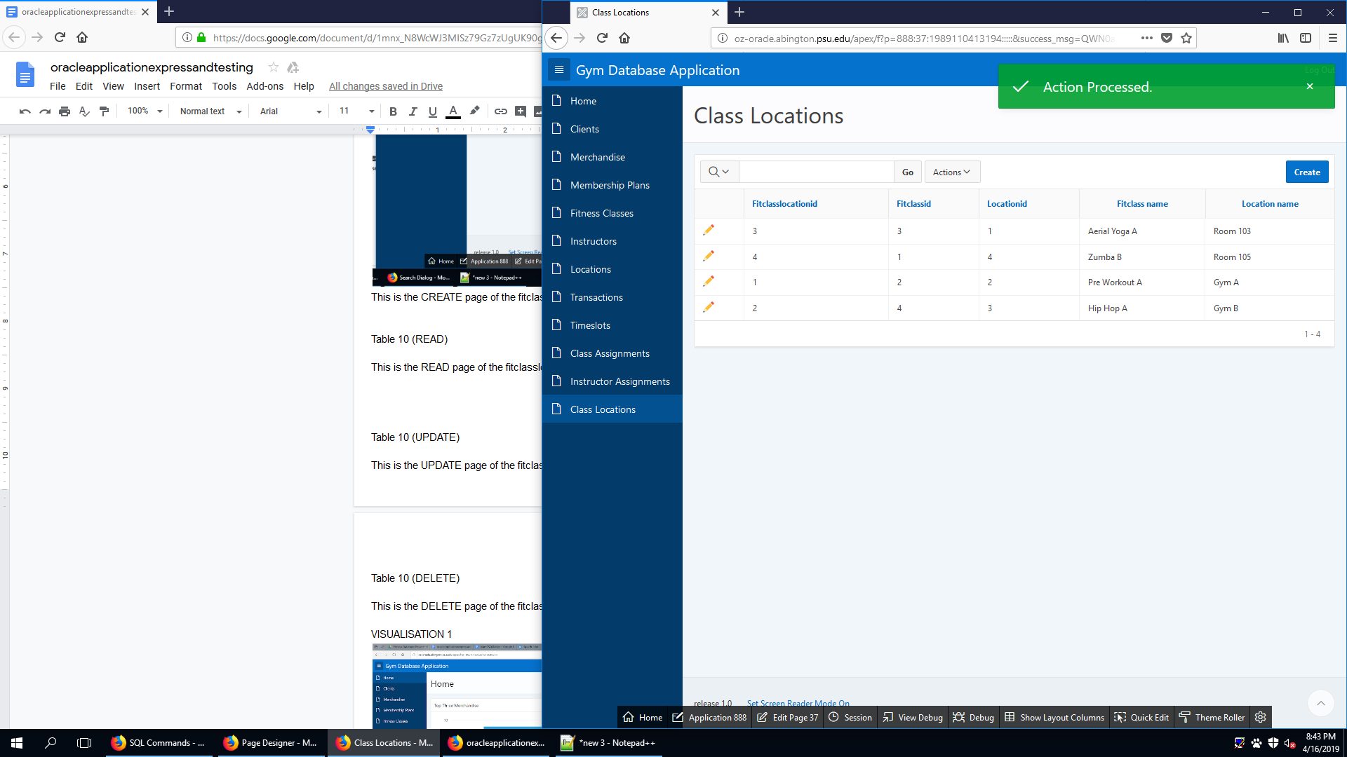

This is the READ page of the fitclasslocation table. It allows the user to see existing class locations.

FITCLASSLOCATION (UPDATE)

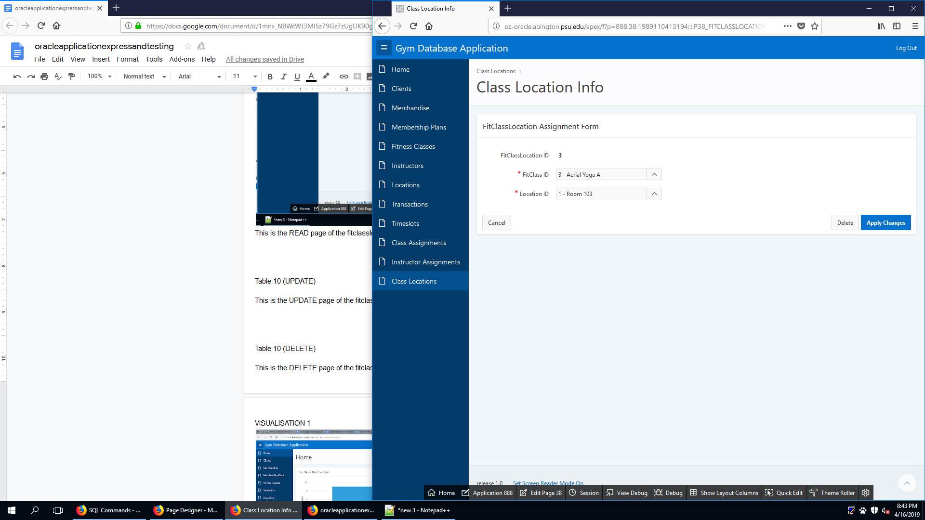

This is the UPDATE page of the fitclasslocation table. It allows the user to update an existing class location.

FITCLASSLOCATION (DELETE)

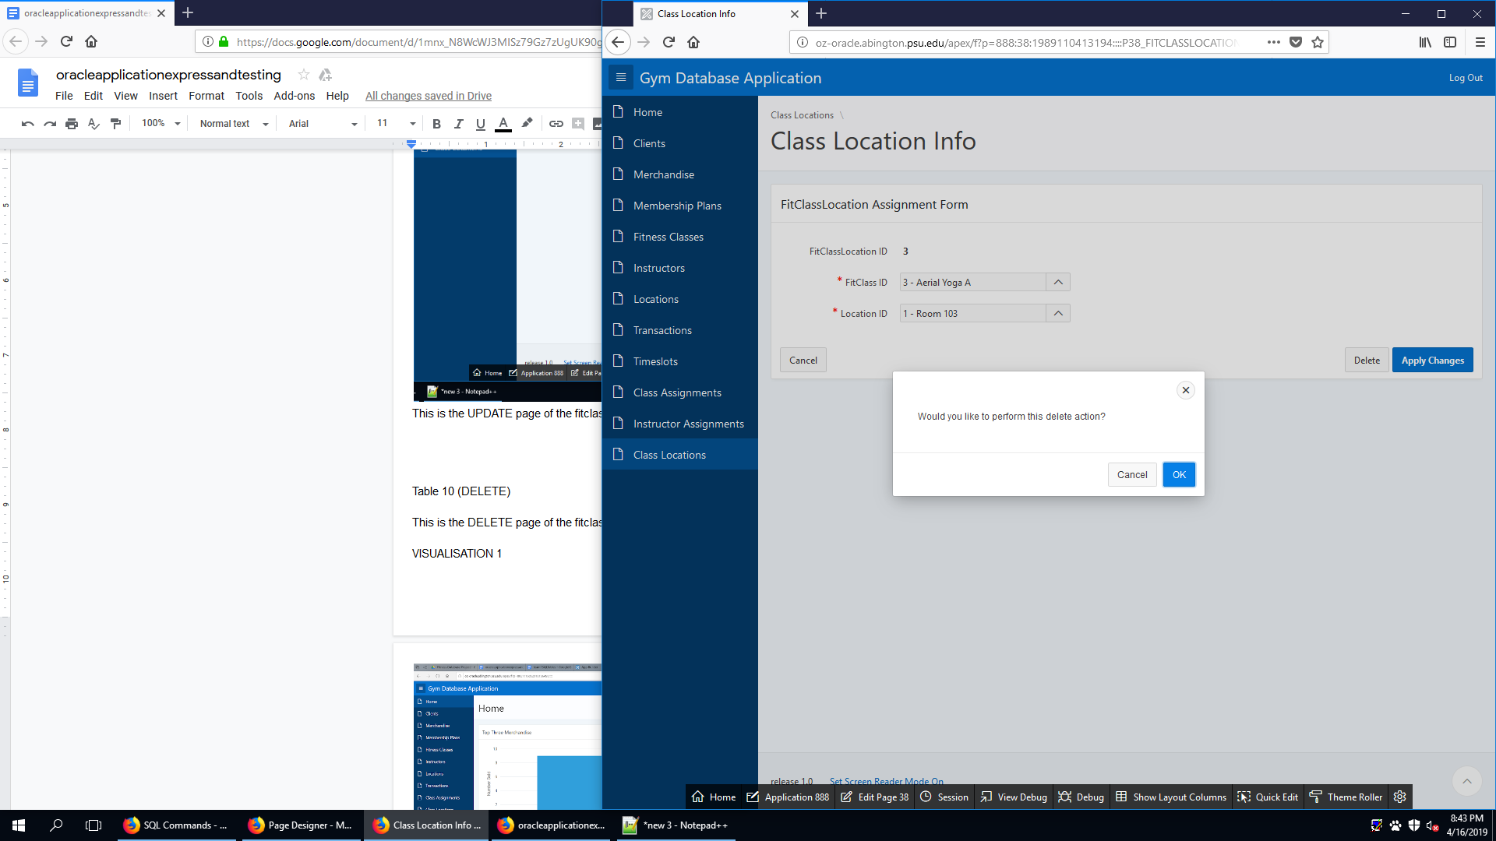

This is the DELETE page of the fitclasslocation table. It allows the user to delete an existing class location.

TIMESLOT (CREATE)

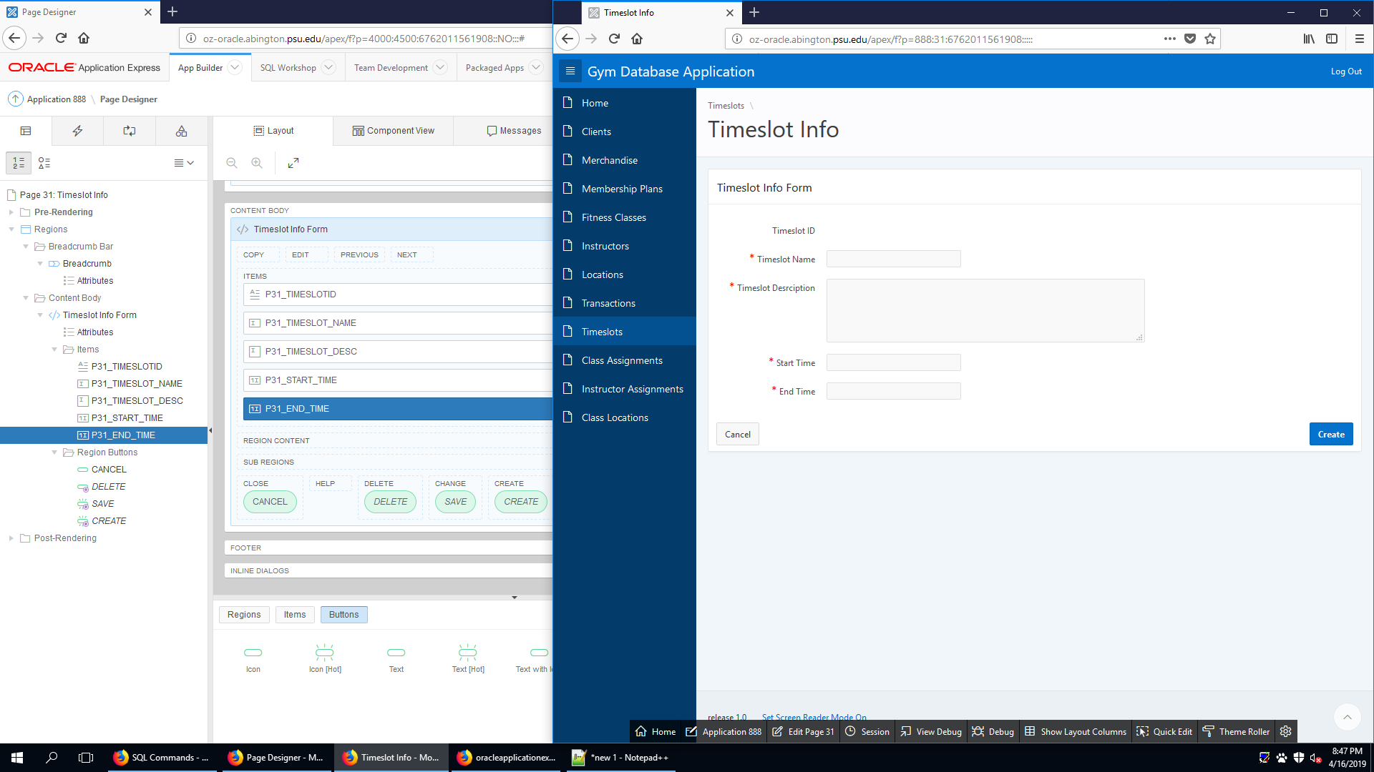

This is the CREATE page of the timeslot table. It allows the user to create new timeslot.

TIMESLOT (READ)

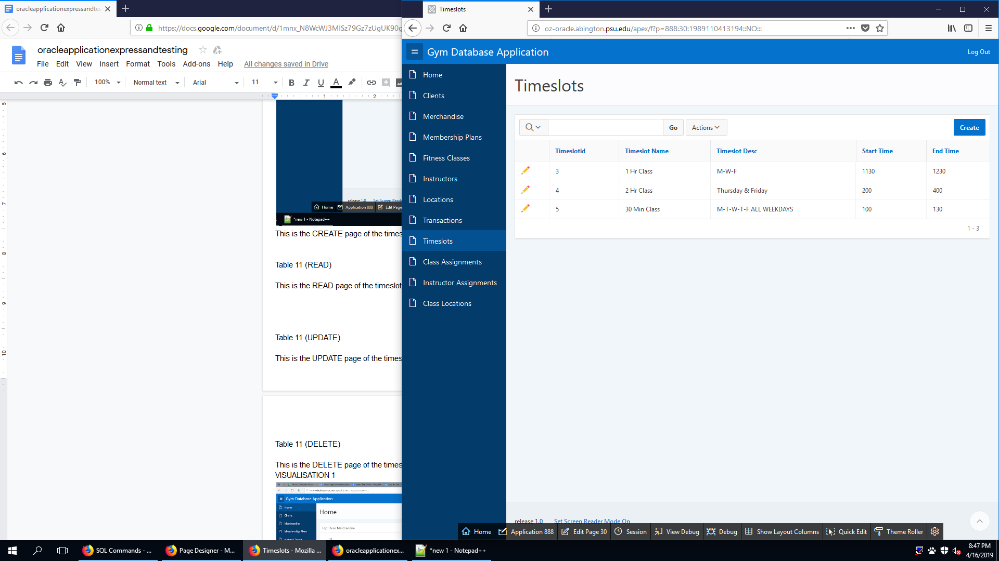

This is the READ page of the timeslot table. It allows the user to see existing timeslot.

TIMESLOT (UPDATE)

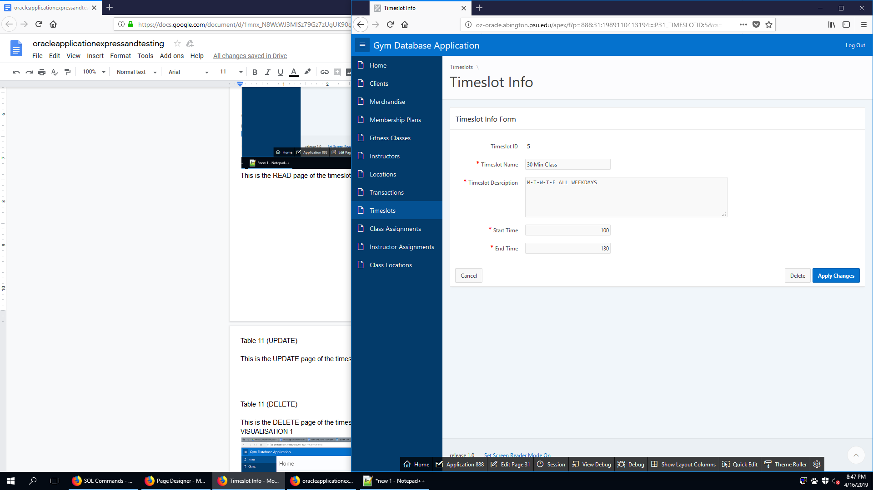

This is the UPDATE page of the timeslot table. It allows the user to update an existing timeslot.

TIMESLOT (DELETE)

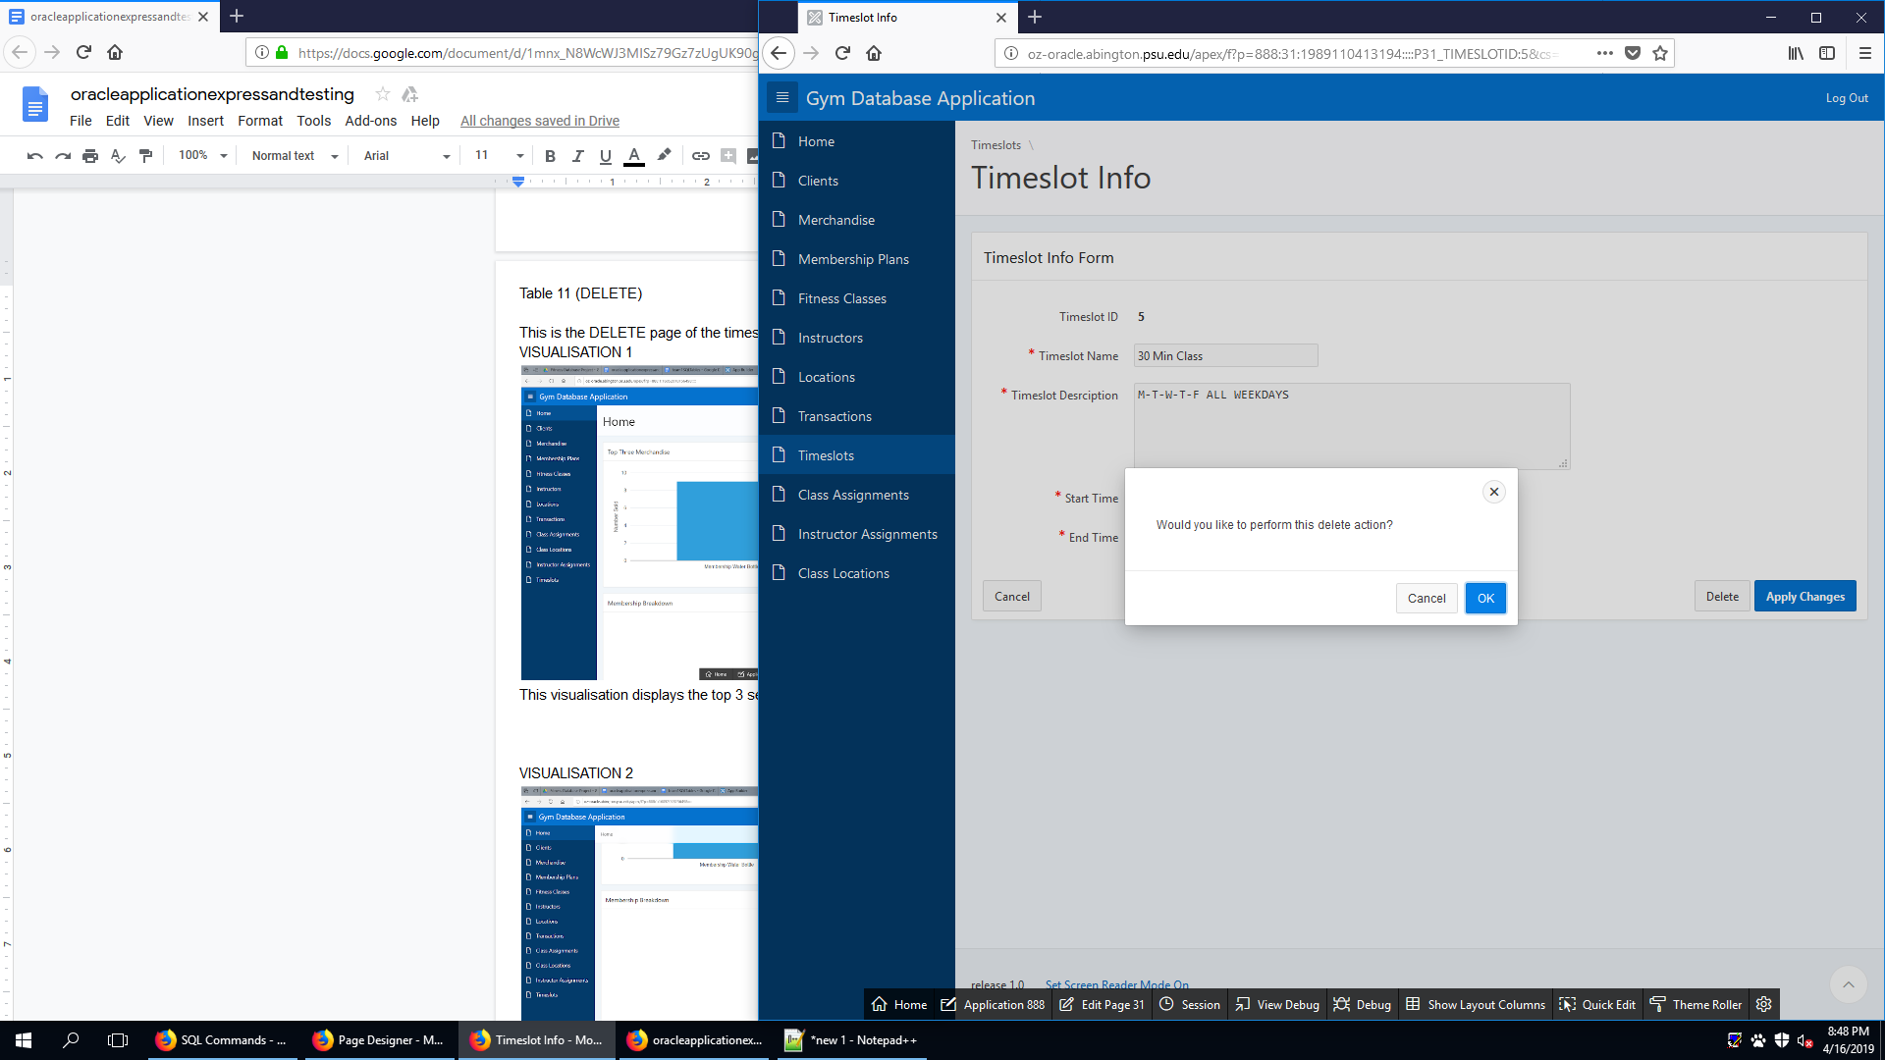

This is the DELETE page of the timeslot table. It allows the user to delete an existing timeslot.

**Visualisations and Reports**

**VISUALISATION 1 - TOP THREE MERCHANDISE**

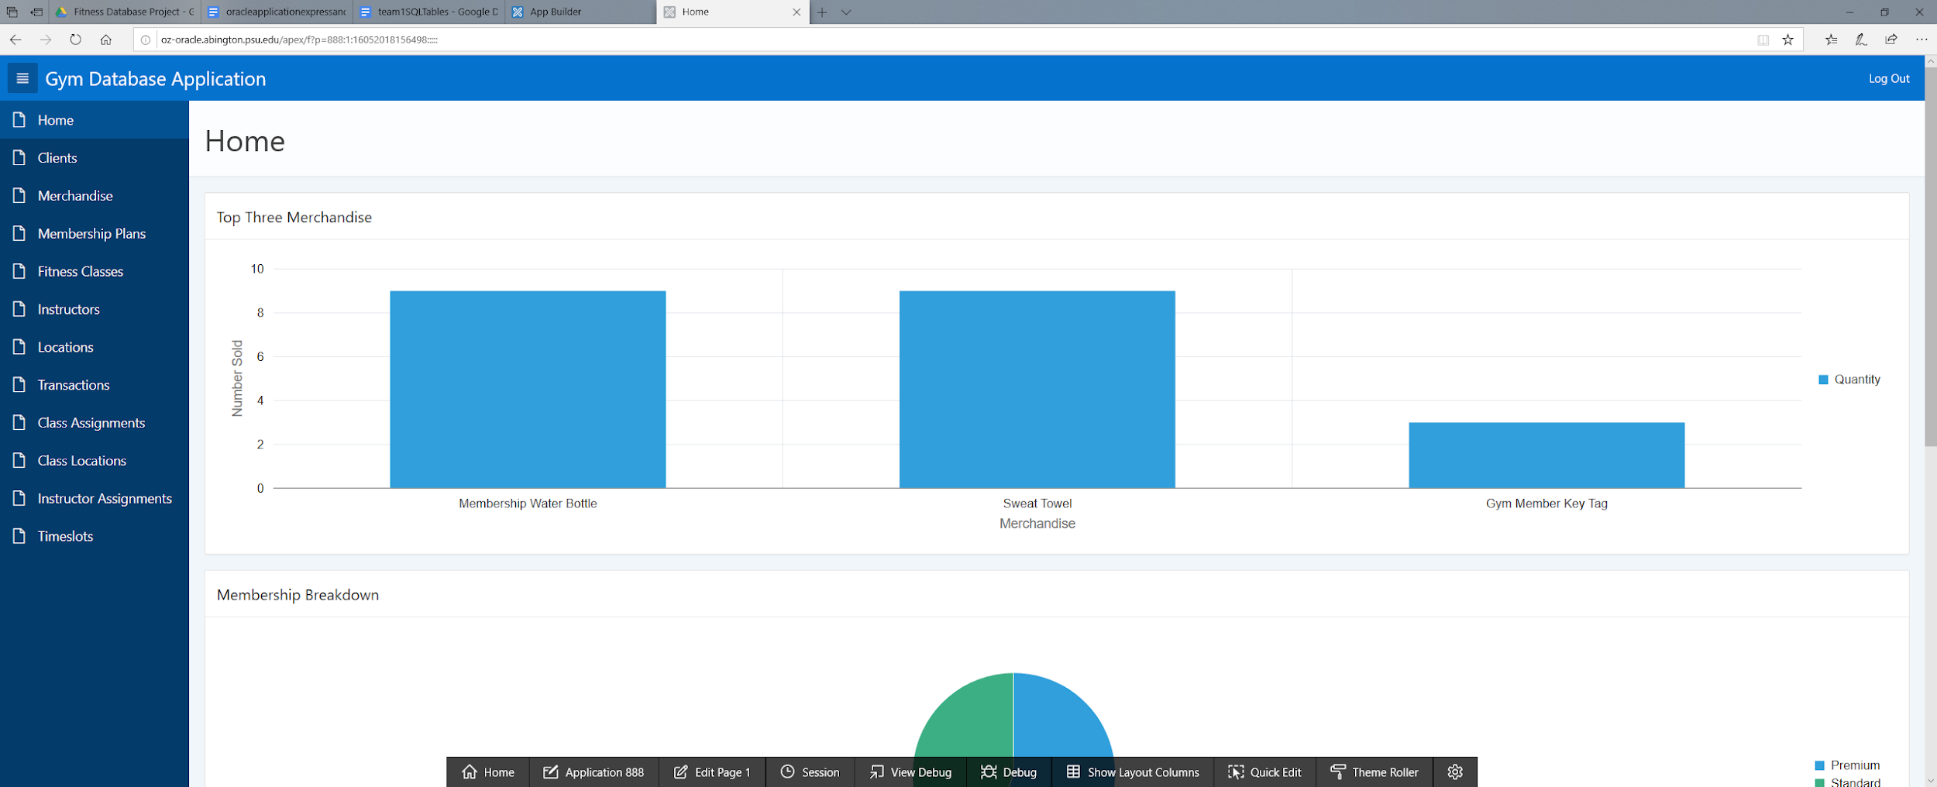

This visualisation displays the top 3 selling merchandise by quantity sold. This allows for an easy visual to see the most popular merchandise sold

**VISUALISATION 2 - MEMBERSHIP DISTRUBUTION**

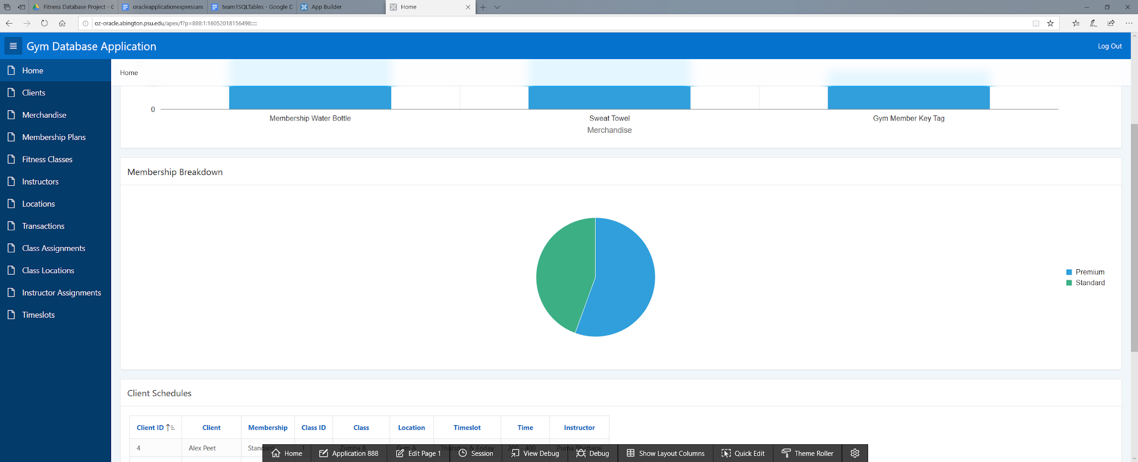

This visualisation shows the proportions of premium versus standard memberships as a pie chart. It allows the user to see which membership is more favored at the moment.

**VISUALISATION 3 - REWARD POINTS**

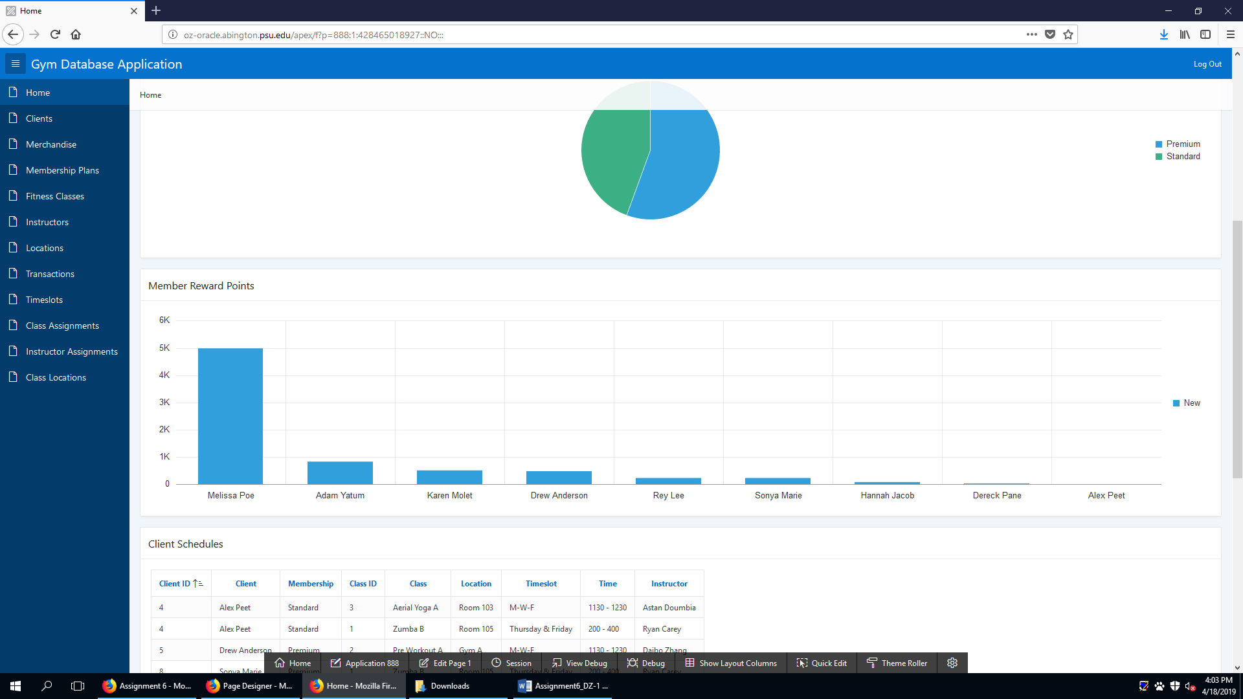

**REPORT 1 - CLIENT SCHEDULES**

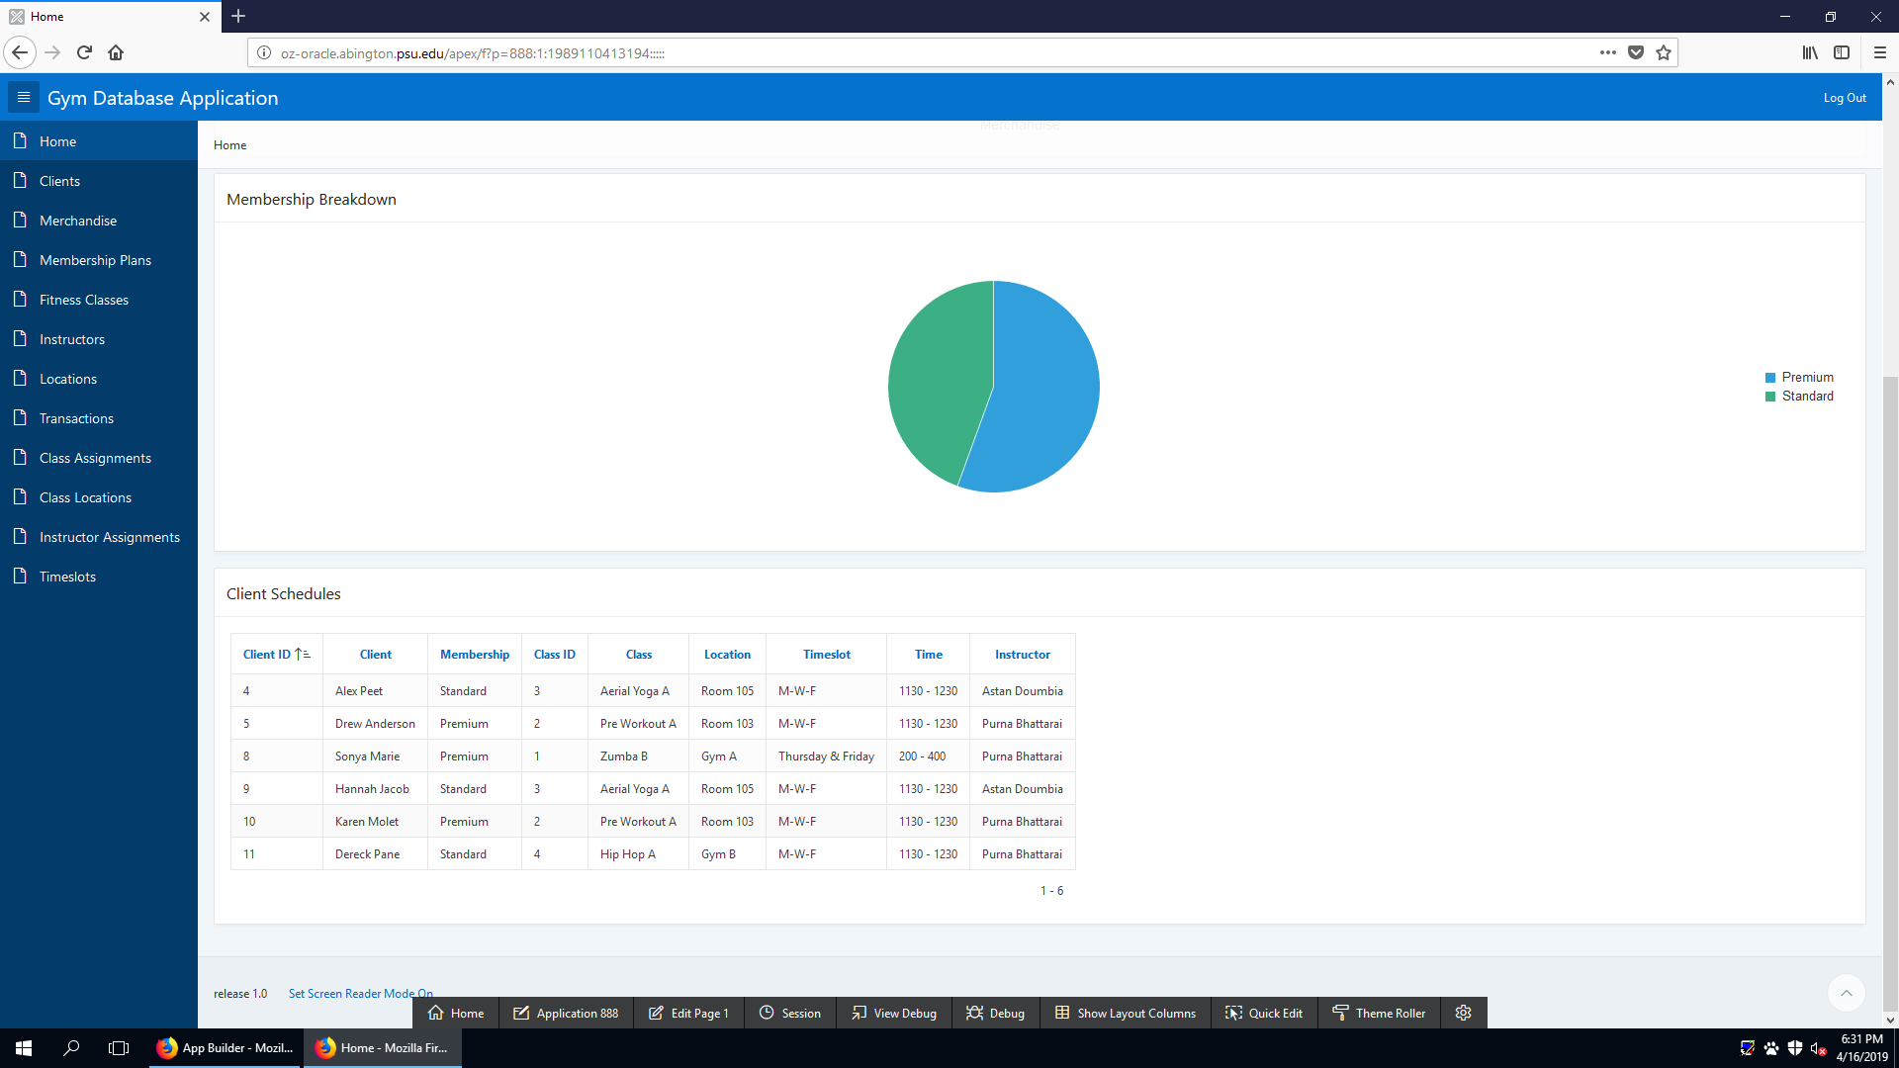

The Client Schedules Report is a one look report that allows the application user to see which clients are assigned to fitness classes. It additionally shows the location and time of each class alongside it’s instructor.

**REPORT 2 - TOP PURCHASES**

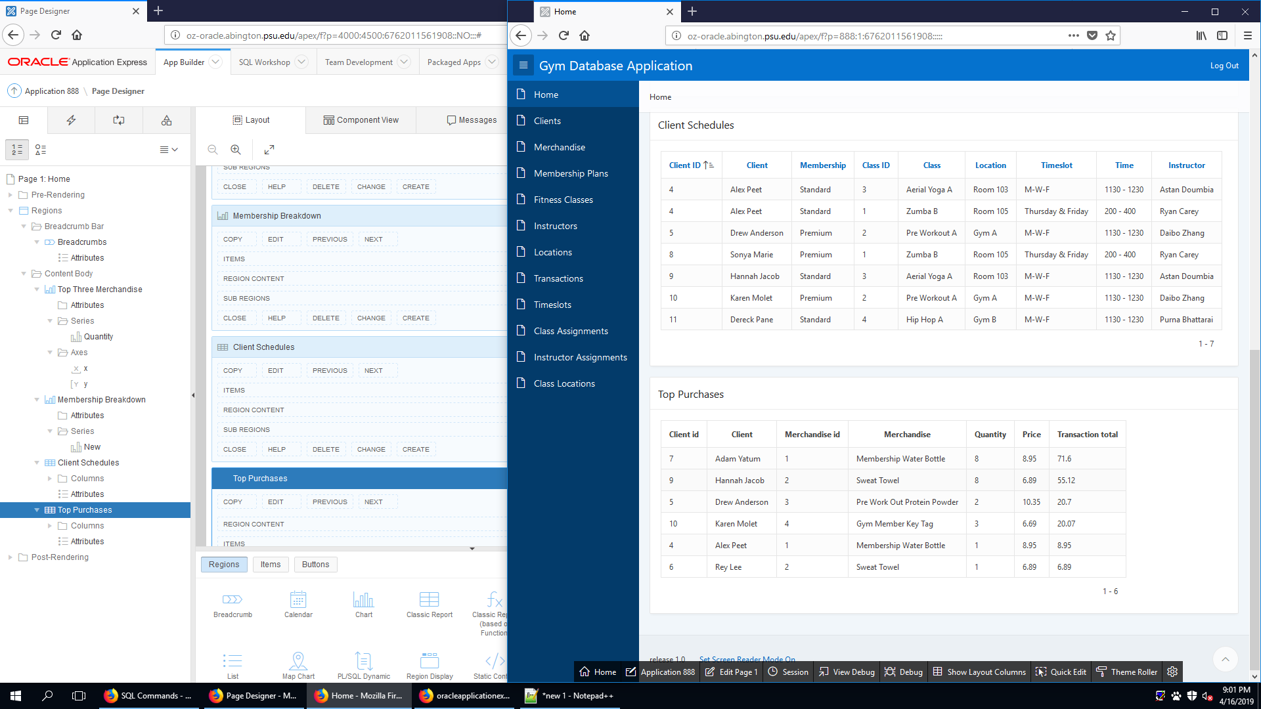

The Top Purchases Report is a one look report that allows the user to see the individual purchases by customer. It shows the customer and merchandise information of the individual purchases sorted by largest purchase descending.